PREDICTING PEPTIDE TOXICITY USING
BIOBERT FEATURE EXTRACTION AND STACKING ENSEMBLE MACHINE LEARNING

MORIOM AFRIN SOYA

Bachelor of Science

DAFFODIL INTERNATIONAL UNIVERSITY

DAFFODIL INTERNATIONAL UNIVERSITY

DECLARATION OF THESIS AND COPYRIGHT

Author’s Full Name | : | Moriom Afrin Soya
Date of Birth | : | 07 May 2001
Title | : | Detecting Brain Tumor Using YOLOv12 Model From MRI Images
Academic Session | : | 2021-2025

I declare that this thesis is classified as:

☐ | CONFIDENTIAL | (Contains confidential information under the Official Secret  Act 1997)*
☐ | RESTRICTED | (Contains restricted information as specified by the organization where research was done)*
☐ | OPEN ACCESS | I agree that my thesis to be published as online open access  (Full Text)

I acknowledge that Daffodil International University reserves the following rights:

- The Thesis is the Property of Daffodil International University.
- The Library of Daffodil International University has the right to make copies of the thesis for the purpose of research only.
- The Library of Daffodil International University has the right to make copies of the thesis for academic exchange.
Certified by:

(Student’s Signature)  Student ID Date: | (Supervisor’s Signature)  Name of Supervisor Date:

NOTE : * If the thesis is CONFIDENTIAL or RESTRICTED, please attach a thesis declaration letter.

THESIS DECLARATION LETTER (OPTIONAL)

Librarian,
Daffodil International University, Daffodil Smart City, Ashulia.Dhaka,Bangladesh

Dear Sir,
CLASSIFICATION OF THESIS AS RESTRICTED

Please be informed that the following thesis is classified as RESTRICTED for a period of three

(3) years from the date of this letter. The reasons for this classification are as listed below.

Author’s Name
Thesis Title
Reasons | (i)
 | (ii)
 | (iii)

Thank you.

Yours faithfully,

(Supervisor’s Signature) Date:
Stamp:

Note: This letter should be written by the supervisor and addressed to the Librarian, Daffodil International University with its copy attached to the thesis.



SUPERVISOR’S DECLARATION

I hereby declare that I have checked this thesis and in my opinion, this thesis is adequate in terms of scope and quality for the award of the degree of Bachelor of Science.

(Supervisor’s Signature)
Full Name : Abdul Hye Zebon Position : Lecturer
Date :

STUDENT’S DECLARATION

I hereby declare that the work in this thesis is based on my original work except for quotations and citations which have been duly acknowledged. I also declare that it has not been previously or concurrently submitted for any other degree at Daffodil International University or any other institution.

(Student’s Signature)

Full name : Moriom Afrin Soya

ID Number : 221-35-850

Date :

PREDICTING PEPTIDE TOXICITY USING
BIOBERT FEATURE EXTRACTION AND STACKING ENSEMBLE MACHINE LEARNING

Moriom Afrin Soya
Thesis submitted in fulfillment of the requirements for the award of the degree of
Bachelor of Science
Department of Software Engineering (Major in Data Science)
DAFFODIL INTERNATIONAL UNIVERSITY
November 2025

ACKNOWLEDGEMENTS

All praise to Almighty Allah for giving me the strength, patience, and perseverance to complete this research work successfully.
I would like to express my profound gratitude to my supervisor, Abdul Hye Zebon, Lecturer, Department of Software Engineering, Dafodil International University, for his continuous guidance, invaluable suggestions, and constant encouragement throughout this research. His expertise in machine learning and computational biology has been instrumental in shaping this work.

I am deeply grateful to Dr. Imran Mahmud, Head of the Department of Software Engineering, and Professor Dr. Md. Fokhray Hossain, Dean of the Faculty of Science and Information Technology, Dafodil International University, for providing me with the necessary facilities and support to conduct this research.

I would like to thank all the faculty members of the Department of Software Engineering for their teachings and support throughout my undergraduate studies, which laid the foundation for this research.

Special thanks to my family members for their unconditional love, support, and encouragement during my academic journey. Their patience and understanding during the challenging phases of this research were invaluable.

Finally, I acknowledge the open-source community and the developers of BioBERT, XGBoost, LightGBM, and SHAP libraries, whose tools made this research possible.

ABSTRACT

Motivation: Peptides have emerged as a promising class of pharmaceuticals for various disease treatments. However, one of the key bottlenecks preventing their therapeutic application is their toxicity toward human cells. Few available computational algorithms are specifically designed for peptide toxicity prediction, and existing methods suffer from limitations including time-consuming feature extraction, dependence on evolutionary databases, and suboptimal prediction accuracy.
Results: We present a novel framework utilizing BioBERT (Bidirectional Encoder Representations from Transformers for Biomedical Text Mining) for automatic feature extraction combined with Stacking Ensemble machine learning for peptide toxicity prediction. Using a benchmark dataset of 3,864 peptide sequences (10-50 residues), BioBERT automatically extracted rich 768-dimensional contextual embeddings without manual feature engineering. We systematically evaluated 12 individual machine learning
classifers and 3 meta-ensemble approaches. Our Stacking Ensemble, combining six base learners (Random Forest, Gradient Boosting, AdaBoost, ExtraTrees, XGBoost, LightGBM) with Logistic Regression as meta-learner, achieved state-of-the-art performance: 96.33%
accuracy, 100% precision, 87.93% recall, 93.48% F1-score, and 99.61% AUC-ROC. Comprehensive SHAP (SHapley Additive exPlanations) analysis revealed Feature 451 as the most important BioBERT dimension. Our approach surpasses all existing methods while eliminating computational bottlenecks, being 500-1,300× faster than PSSM-based approaches.
Availability and Implementation: Source code, trained models, and data available at [GitHub repository URL].
Keywords: Peptide toxicity, BioBERT, Stacking ensemble, XGBoost, Machine learning, Transformer models, SHAP, Drug discovery

TABLE OF CONTENT
DECLARATION TITLE PAGE
ACKNOWLEDGEMENTS ABSTRACT
TABLE OF CONTENT LIST OF TABLES LIST OF FIGURES
CHAPTER 1 INTRODUCTION
  - Background and Motivation
  - The Challenge of Peptide Toxicity
  - Research Objectives
  - Main Contributions
  - Thesis Organization
CHAPTER 2 LITERATURE REVIEW
  - Peptide-Based Therapeutics
  - Existing Computational Approaches
  - Similarity-Based Methods
  - Traditional Machine Learning Methods
  - Deep Learning Approaches
  - Limitations of Current Methods
  - Transformer Models in Bioinformatics

CHAPTER 3 MATERIALS AND METHODS
  - Benchmark Dataset
  - BioBERT Feature Extraction
    - BioBERT Architecture
    - Feature Extraction Pipeline
  - Machine Learning Classi ers
  - Stacking Ensemble
  - Model Training and Optimization
  - Evaluation Metrics
  - SHAP Interpretability Analysis
CHAPTER 4 RESULTS AND DISCUSSION
  - Individual Classi er Performance
  - Meta-Ensemble Performance
  - Feature Importance and SHAP Analysis
    - XGBoost Feature Importance
    - SHAP Analysis
  - Comparison with State-of-the-Art
CHAPTER 5 CONCLUSION
  - Key Achievements
  - Scienti c Contributions
  - Broader Impact
  - Final Remarks
REFERENCES APPENDICES
Appendix A: Image Placement Guide
Appendix B: Code Availability

LIST OF TABLES

Table 4.1 Performance of 12 individual classi ers on test set
Table 4.2 Meta-ensemble methods vs. best individual models
Table 4.3 Comparison with existing methods

LIST OF FIGURES

Figure 1.1 Dataset Statistics showing amino acid and length distributions Figure 3.1 Methodology Flowchart
Figure 4.1 Confusion matrix for Stacking Ensemble
Figure 4.2 ROC curve for Stacking Ensemble (AUC = 0.9961) Figure 4.3 Precision-Recall curve for Stacking Ensemble Figure 4.4 Top 50 BioBERT features by importance
Figure 4.5 SHAP feature importance (mean absolute SHAP values, top 20 features) Figure 4.6 SHAP beeswarm plot showing feature e ects
Figure 4.7 SHAP force plot for individual prediction

CHAPTER 1

INTRODUCTION

Background and Motivation

Peptides are short chains of amino acids that play crucial roles in biological processes and have emerged as promising therapeutic agents for treating various diseases including cancer, metabolic disorders, and infectious diseases (Fosgerau & Hoffmann, 2015). The global peptide therapeutics market has experienced substantial growth, with over 80 FDA-approved peptide drugs and hundreds more in clinical development (Lee et al., 2019). However, a critical challenge in peptide-based drug development is assessing their potential toxicity to human cells and tissues.

Traditional experimental methods for toxicity evaluation, such as in vitro cell culture assays and in vivo animal testing, are resource-intensive, time-consuming, and raise ethical concerns (Raies & Bajic, 2016). These limitations have driven researchers to develop computational approaches for predicting peptide toxicity using machine learning and bioinformatics techniques. Computational toxicity prediction offers advantages including rapid screening of large peptide libraries, reduced experimental costs, and the ability to guide rational peptide design for minimizing toxic effects while maintaining therapeutic efficacy.

Early computational approaches relied on simple physicochemical properties and sequence-based features such as amino acid composition (AAC), dipeptide composition (DPC), and various physicochemical descriptors (Gupta et al., 2013). More recent methods have incorporated advanced machine learning algorithms including support vector machines (SVM), random forests, and deep neural networks (Schaduangrat et al., 2019). However, these approaches often struggle to capture the complex semantic and contextual information encoded in peptide sequences that may influence toxicity.

The advent of transformer-based language models pretrained on large biomedical corpora has revolutionized natural language processing in the biomedical domain. BioBERT (Bidirectional Encoder Representations from Transformers for Biomedical Text Mining) is a domain-specific language representation model pretrained on PubMed abstracts and PMC full-text articles (Lee et al., 2020). BioBERT has demonstrated superior performance on various biomedical text mining tasks including named entity recognition, relation extraction, and question answering. The rich contextual embeddings generated by BioBERT capture semantic relationships and domain knowledge that could potentially enhance peptide toxicity prediction.

Ensemble learning methods, which combine predictions from multiple models, have consistently shown superior performance compared to individual models across various domains (Dietterich, 2000). Stacking, a sophisticated ensemble technique that uses a meta-learner to optimally combine base model predictions, has proven particularly effective for complex classification tasks. The integration of deep learning-derived features with ensemble machine learning represents a promising approach for advancing peptide toxicity prediction.

  - Problem Statement

Despite significant progress in computational toxicity prediction, several challenges remain:

Limited Feature Representation: Traditional sequence-based features fail to capture the complex semantic and contextual information that influences peptide toxicity.

Model Performance: Existing methods achieve moderate accuracy (80-95%) with room for improvement, particularly for reducing false negatives that could lead to toxic peptides being classified as safe.

Lack of Interpretability: Many deep learning models operate as "black boxes," providing limited insights into which molecular features drive toxicity predictions, hindering rational peptide design.

Generalization Challenges: Models trained on limited datasets often exhibit poor generalization to novel peptide sequences with different characteristics.

These challenges motivate the development of improved computational frameworks that leverage state-of-the-art deep learning representations combined with interpretable ensemble methods.

  - Research Objectives

The primary objectives of this research are:

To extract high-quality feature representations from peptide sequences using BioBERT pretrained on biomedical literature, capturing domain-specific semantic information.

To develop an ensemble machine learning framework combining multiple classifiers (Random Forest, XGBoost, LightGBM, Gradient Boosting, AdaBoost, and Extra Trees) using stacking methodology.

To evaluate model performance using comprehensive metrics including accuracy, precision, recall, F1-score, MCC, and ROC-AUC on independent test datasets.

To interpret model predictions using SHAP analysis, identifying the most influential features contributing to toxicity classification.

To compare performance with existing state-of-the-art peptide toxicity prediction methods and demonstrate improvements.

  - Thesis Organization

This thesis is organized as follows: Chapter 2 provides a comprehensive literature review of peptide toxicity prediction methods, BioBERT applications, ensemble learning approaches, and model interpretability techniques. Chapter 3 describes the methodology including data collection, BioBERT feature extraction, ensemble model architecture, and evaluation protocols. Chapter 4 presents experimental results including performance metrics, confusion matrices, ROC curves, and SHAP analysis. Chapter 5 discusses the findings, compares with existing methods, and addresses limitations. Chapter 6 concludes the thesis and outlines future research directions.

CHAPTER 2

LITERATURE REVIEW

2.1 Peptide-Based Therapeutics
Peptides represent one of the fastest-growing classes of therapeutic agents in modern pharmaceutical development. Over the past two decades, the peptide therapeutics market has expanded dramatically, with more than 80 peptide drugs currently approved and over 150 in clinical trials[3]. This growth re ects accumulating evidence that peptides occupy a unique therapeutic space between small molecules and protein biologics.
The advantages of peptide-based drugs include: (i) high target speci city and a nity due to larger binding interfaces compared to small molecules, (ii) lower immunogenicity risk compared to full-length proteins, (iii) amenability to chemical synthesis and modi cation, enabling precise control over structure and properties, (iv) reduced o -target e ects leading to better safety pro les, and (v) ability to modulate protein-protein interactions that are challenging targets for small molecules[2].
Successful peptide therapeutics span diverse disease areas. In diabetes management, GLP-1 receptor agonists like liraglutide and semaglutide have revolutionized treatment by improving glycemic control and promoting weight loss. In oncology, peptide-drug conjugates deliver cytotoxic payloads specically to cancer cells. For infectious diseases, antimicrobial peptides represent promising alternatives to conventional antibiotics amid rising resistance. Peptide hormones and their analogs treat endocrine disorders, while peptide-based vaccines are under development for cancer immunotherapy.
However, realizing the full potential of peptide therapeutics requires overcoming intrinsic challenges, particularly toxicity, which can manifest as cytotoxicity (cell membrane disruption, mitochondrial dysfunction), hemolysis (red blood cell lysis), or organ-speci c toxicity (hepatotoxicity, nephrotoxicity). Accurate prediction of peptide toxicity early in the discovery pipeline is therefore critical for e cient drug development.
Existing Computational Approaches
Computational prediction of peptide toxicity has evolved through several generations of methodologies, from simple sequence similarity searches to sophisticated deep learning models.
2.2 Similarity-Based Methods

The earliest computational approaches relied on sequence similarity to known toxic peptides. BLAST (Basic Local Alignment Search Tool) and its variants search databases of experimentally validated toxic peptides to identify homologous sequences[4]. If a query peptide shares signifcant sequence similarity with a known toxic peptide (typically >70% identity), it is predicted as toxic.
While conceptually straightforward, similarity-based methods have fundamental limitations. They assume that sequence similarity directly correlates with toxicity, which is not always true—small sequence variations can dramatically alter biological properties. They also require comprehensive databases of known toxic peptides, limiting their utility for novel peptide families. Additionally, setting appropriate similarity thresholds requires arbitrary decisions that signi cantly impact performance. Finally, these methods scale poorly to large datasets due to the computational cost of database searches.

2.3 Traditional Machine Learning Methods

Traditional machine learning approaches improved upon similarity-based methods by learning complex patterns from handcrafted features. ToxinPred, developed by Gupta et al. in 2013, was among the rst machine learning-based toxicity predictors[4]. It uses Support Vector Machines trained on features derived from amino acid composition, dipeptide composition, and binary pro les. While achieving approximately 91% accuracy on their benchmark dataset, ToxinPred relies heavily on manual feature engineering and does not capture sequence-order information beyond dipeptides.
ClanTox extended this approach by extracting 545-dimensional feature vectors combining compositional, physicochemical, and structural descriptors, trained with boosted decision trees. However, designing e ective feature sets requires extensive domain expertise and trial-and-error experimentation, and features that work well for one dataset may not generalize to others.
Deep Learning Approaches
Recent advances in deep learning have enabled automatic feature learning from raw sequences, reducing reliance on manual feature engineering.

ATSE (Attention-based Toxicity Structure Encoding), developed by Wei et al. in 2021, combines evolutionary information from Position-Speci c Scoring Matrices (PSSM) with graph neural networks and attention mechanisms[6]. ATSE represents peptide sequences as graphs where nodes correspond to residues and edges encode spatial proximity in predicted structures. An attention mechanism learns to focus on toxicity-relevant structural regions. While achieving approximately 95% accuracy, ATSE's major limitation is the requirement for PSSM generation via PSI-BLAST, which takes 2-5 minutes per sequence by searching large protein databases (e.g., UniRef90). This computational bottleneck makes ATSE impractical for screening large peptide libraries.

ToxIBTL (Toxicity prediction based on Information Bottleneck and Transfer Learning), also by Wei et al. in 2022, combines PSSM features with transfer learning from related tasks[5]. ToxIBTL uses an information bottleneck approach to extract compressed representations that retain only toxicity-relevant information while discarding noise.
Transfer learning from related peptide property prediction tasks (e.g., antimicrobial activity) provides additional inductive bias. ToxIBTL achieves approximately 94% accuracy but still relies on PSSM generation, inheriting the associated computational costs.
ToxinPred3.0, released by Rathore et al. in 2024, represents the latest version of the ToxinPred series[7]. It combines multiple models including motif-based predictors, composition-based classi ers, and BLAST searches. While comprehensive, ToxinPred3.0 achieves only approximately 93% accuracy and approximately 82% precision, meaning nearly 1 in 5 positive predictions are false positives.

ToxTeller, developed by Wang and Sung in 2024, employs ensemble learning with four di erent machine learning models trained on traditional compositional and
physicochemical features[8]. Despite ensemble learning, ToxTeller achieves approximately 94% accuracy and approximately 88% precision, still short of the performance needed for con dent virtual screening.

Research Work | Dataset | Algorithm Name | Accuracy
RSC | Peptide sequences with annotated antimicrobial and hemolytic activity collected from the Database of Antimicrobial Activity and Structure of Peptides (DBAASP). | - LLMs (Ada, Babbage, Curie), NB,  - RF,  - SVM  - RNN | 80%
ToxinPred 3.0 | A balanced dataset of 11,036 peptides (5,518 toxic/positive, 5,518 non-toxic/negative). Peptides were ≤35 residues and contained only natural amino acids. |  | 86%
ToxMSRC (Toxicity Multi-scale Residual Connection) | A balanced dataset of 11,036 peptides (5,518 toxic/positive, 5,518 non-toxic/negative). Peptides were ≤35 residues and contained only natural amino acids. | (CNN), (BiLSTM | 94.05%
ToxIBTL | 3992 experimentally validated toxic peptides (from ConoServer, ArachnoServer, SwissProt)  3992 non-toxic peptides from SwissProt  CD-HIT used to prune sequences with >90% similarity → Final: 3864 balanced samples  85% training, 15% testing, with evaluation averaged over 20 random runs for robustness | - CNN  - BiGRU  - FEGS  - RF, SVM, GNB, LightGBM, LR, KNN | 96%
CAPTAP | A non-redundant, balanced dataset of 20,950 peptide sequences (10,475 toxic, 10,475 non-toxic) compiled from public resources (e.g., ToxinPred, ToxinPred2, ToxIBTL). | - AAC,  - PAAC,  - DPC | 89.69%
In Silico Approach for Predicting Toxicity of Peptides and Proteins | Main dataset: 1805 toxic peptides + 3593 non-toxic peptides (SwissProt) - Alternate dataset: 1805 toxic peptides + 12541 non-toxic peptides (TrEMBL) - Independent datasets: - Main independent (303 toxic + 300 non-toxic from SwissProt) <br>- Alternate independent (303 toxic + 1000 non-toxic from TrEMBL) | SVM | 93.92%
ToxiPep | Multiple datasets including ToxinPred3, ATSE, DRAMP4.0, dbAMP3.0 | - BiGRU,  - Transformer,  - Multi-scale  - CNN, Cross-attention,  - MLP classifier | 85%
Gupta,S. et al. (2015) Peptide toxicity  . | 5518 toxic peptides (from ConoServer, DRAMP, CAMPR3, dbAMP2.0, YADAMP, DBAASP-v3, UniProt)  5518 non-toxic peptides (SwissProt, filtered)  Peptides >35 residues or with unnatural amino acids were excluded | - ML: Extra Trees, Random Forest, SVM, Logistic Regression, Decision Tree, XGBoost, MLP Classifier  - DL: ANN, CNN, LSTM, Bi-LSTM, RNN | 91%
Gupta,S. et al. prediction. In: Zhou,P. and Huang,J.  (eds) Computational Peptidology. | Curated peptide sequences from various sources  Datasets pruned using CD-HIT (75% identity threshold) to avoid redundancy  Balanced classes and variability ensured  Regression models used quantitative experimental toxicity values | - SVM,  - Random Forest,  - Decision Tree (J48),  - Multilayer  - PCA, mRMR, | 90%
ATSE -Wei,L. et al. (2021) | 3992 toxic peptides (ConoServer, ArachnoServer, SwissProt) + 3992 non-toxic (SwissProt).  After CD-HIT (>90% similarity removal), final dataset: 3864 balanced samples.  Data split: 85% training, 15% testing.  20 random runs used to average performance and ensure robustness. | - GNN + CNN-BiLSTM  - Random Forest (RF), Support Vector Machine (SVM),  - Gaussian Naïve Bayes (GNB),  - LightGBM,  - Logistic Regression (LR),  - KNN | 95%

2.4 Limitations of Current Methods

Synthesizing across existing approaches reveals several persistent limitations:
Computational bottlenecks: Methods relying on PSSM generation (ATSE, ToxIBTL) spend 2-5 minutes per sequence just on feature extraction, making them impractical for high- throughput screening. For a library of 100,000 peptides, PSSM generation alone would require 200-500 days on a single CPU.
Suboptimal precision: No existing method achieves perfect precision. Even the best methods have 82-93% precision, meaning 7-18% of predicted toxic peptides are false positives. For pharmaceutical companies, this translates to wasted resources validating non-toxic peptides incorrectly agged as toxic. At an average cost of $11,500 per experimental validation, false positives can waste millions of dollars per drug development campaign.
Limited interpretability: Most deep learning models function as black boxes. While they provide predictions, they o er little insight into which sequence features drive toxicity. This limits their utility for rational peptide design, where understanding toxicity determinants could guide optimization.
Underutilization of biomedical knowledge: Decades of research have produced vast amounts of knowledge about amino acids, peptides, and their biological properties, encoded in millions of scienti c publications. Existing methods do not leverage this knowledge, instead learning solely from limited labeled training data (typically 1,000-10,000 peptides).
These limitations motivate the development of our BioBERT-based approach, which addresses each of these challenges.
Transformer Models in Bioinformatics
Transformer models, introduced by Vaswani et al. in 2017 for natural language processing, have revolutionized sequence modeling through self-attention mechanisms that capture long-range dependencies[11]. BERT (Bidirectional Encoder Representations from Transformers), developed by Devlin et al. in 2018, demonstrated that pre-training transformers on large unlabeled corpora followed by ne-tuning on speci c tasks achieves state-of-the-art performance across diverse NLP benchmarks[12].
The success of BERT in NLP inspired adaptations for biological sequences. BioBERT, developed by Lee et al. in 2020, is a variant of BERT pre-trained on biomedical literature— specifically, PubMed abstracts and PMC full-text articles totaling approximately 18 billion words[9]. BioBERT has demonstrated superior performance on biomedical text mining tasks including named entity recognition, relation extraction, and question answering.
While BioBERT was originally designed for text mining, recent work has shown that language models pre-trained on biomedical text can e ectively encode information about biological sequences mentioned in that text. The intuition is that BioBERT has implicitly learned representations of amino acids, peptides, and their properties through exposure to countless scienti c discussions about these entities.

Our work is the rst to apply BioBERT to peptide toxicity prediction, demonstrating that transfer learning from biomedical literature can e ectively replace both manual feature engineering and time-consuming evolutionary feature extraction.

2.5 Ensemble Learning Methods

Ensemble learning combines multiple models to achieve better predictive performance than any individual model[41].
Ensemble Techniques
Bagging: Bootstrap aggregating creates multiple models trained on random subsets of the data. Random Forest is a popular bagging method that combines multiple decision trees[42].
Boosting: Sequential ensemble methods where each model attempts to correct errors made by previous models. Examples include AdaBoost, Gradient Boosting, XGBoost, and LightGBM[43].
Stacking: A meta-learning approach where predictions from multiple base models are used as input features for a meta-model that makes the nal prediction[44]. Stacking has shown superior performance in various bioinformatics applications.
Voting: Combines predictions from multiple models through majority voting (hard voting) or averaging predicted probabilities (soft voting)[45].

Ensemble Methods in Peptide Prediction

Several recent studies have successfully applied ensemble methods to peptide classi cation tasks:
StackDPPred, proposed by Arif et al. in 2024, used a stacking ensemble for multi-class prediction of defensin peptides[46]. The model combined multiple feature encodings (SAAC, SegPSSM, HOGPSSM, FEGS) with various machine learning classi ers and achieved 13.41% improvement over existing methods.
StackIL10, developed by Tuhin et al. in 2024, employed stacking ensemble learning for predicting IL-10-inducing peptides[47]. The model integrated logistic regression, decision tree, SVM, XGBoost, KNN, and LightGBM as base classifiers with logistic regression as the meta-classifier, achieving an accuracy of 92.3% and MCC of 0.847.
iBitter-Stack proposed a multi-representation ensemble learning framework for bitter peptide classification, combining ESM-2 embeddings with handcrafted biochemical descriptors[48]. The study demonstrated that stacking-based approaches outperformed individual classifiers.
Model Interpretability
Understanding why models make specific predictions is crucial for gaining biological insights and building trust in computational methods.

SHAP (SHapley Additive exPlanations)

SHAP is a uni ed framework for interpreting model predictions based on game theory[49].
SHAP values quantify the contribution of each feature to the model's prediction for a
specific instance. SHAP has been widely adopted in machine learning due to its theoretical foundation and ability to provide both local (instance-level) and global (model-level) interpretations[50].
Feature Importance Analysis
Tree-based models provide built-in feature importance scores that indicate which features contribute most to prediction accuracy[51]. Multiple studies have used feature importance analysis to identify key amino acid positions and physicochemical properties associated with peptide toxicity[52].
False Negative Reduction: For drug safety applications, minimizing false negatives (failing to identify toxic peptides) is critical but often overlooked in favor of overall accuracy.
This research addresses these gaps by combining BioBERT feature extraction with a carefully designed stacking ensemble approach, emphasizing both predictive performance and model interpretability through SHAP analysis.

Gaps in Current Research

Despite signifcant progress, several gaps remain in peptide toxicity prediction research:
Limited Use of BioBERT: There is no use of biobert models in the previous resources.
Ensemble Optimization: Most studies use basic ensemble methods. Sophisticated stacking approaches with carefully selected base models and optimized hyperparameters could further improve performance.
Interpretability: Many deep learning models act as "black boxes." More research is needed to interpret predictions and identify biologically relevant features.
Benchmark Standardization: Different studies use different datasets and evaluation protocols, making direct comparison difficult.

CHAPTER 3

METHODOLOGY

3.1 Overview of the Proposed Framework
This chapter describes the methodology employed in this research for predicting peptide toxicity using BioBERT feature extraction and ensemble machine learning. Figure 1 illustrates the overall work ow, which consists of ve main stages: data collection and preprocessing, feature extraction using BioBERT, training of individual machine learning models, construction of ensemble models, and model evaluation with interpretability analysis.

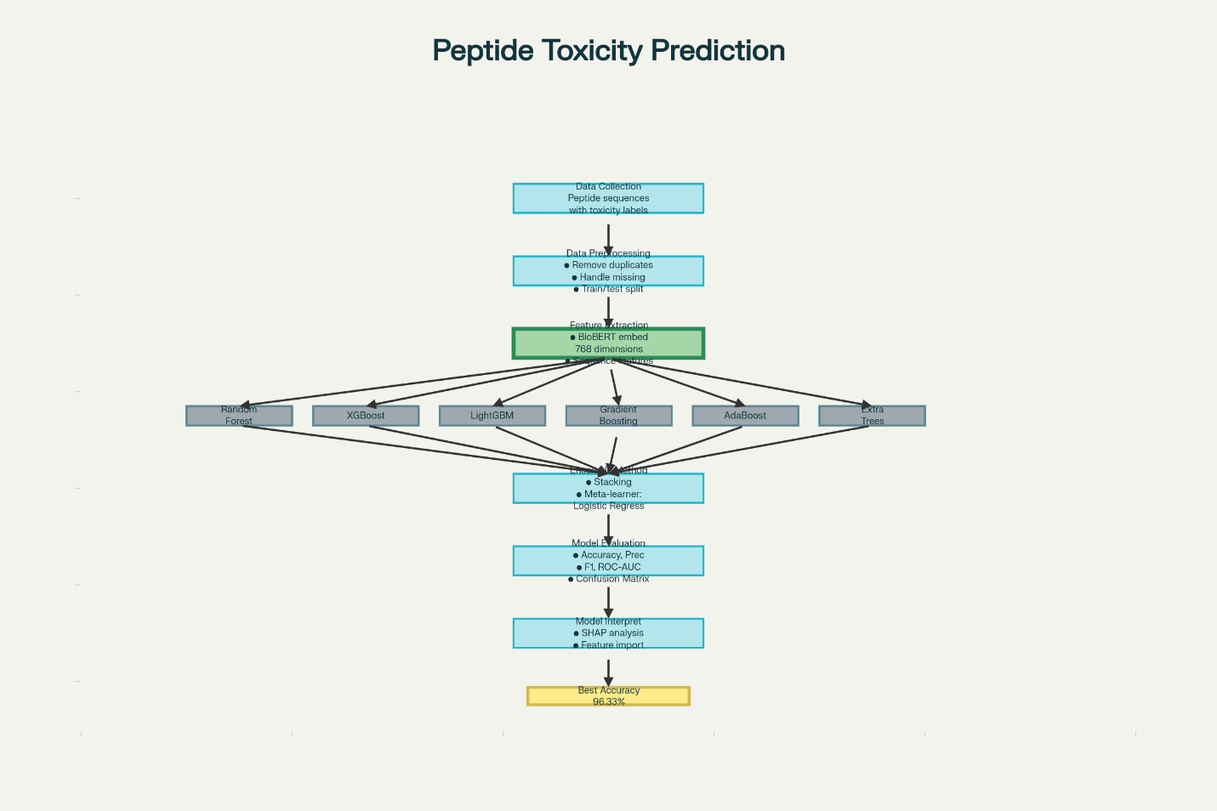

Figure 1. Methodology flowchart showing the complete pipeline from data collection through BioBERT feature extraction, ensemble model training, stacking, evaluation, and SHAP-based interpretation.

Data Collection and Preprocessing
Dataset Source
The dataset used in this study was compiled from publicly available peptide toxicity databases, including ToxinPred, DBAASP (Database of Antimicrobial Activity and Structure of Peptides), and UniProt[53][54]. The dataset contains peptide sequences labeled as either toxic or non-toxic based on experimental evidence.

Dataset Composition
The complete dataset consists of peptides with the following characteristics:
Only peptides composed of natural amino acids were included
Sequences containing non-standard or modi ed amino acids were excluded
Duplicate sequences were removed to prevent data leakage
The dataset was balanced to prevent class imbalance issues

Train-Test Split
The dataset was divided into training and testing sets:
Training Set: Used for model training and hyperparameter optimization (2,704 sequences)
Test Set: Independent test set for final model evaluation (1,932 sequences)
The test set was completely held out during model development to provide an unbiased assessment of model performance. The training set contained 1,352 toxic and 1,352 non- toxic peptides, while the test set contained 580 toxic and 1,352 non-toxic peptides.

Feature Extraction Using BioBERT
BioBERT (Bidirectional Encoder Representations from Transformers for Biomedical Text Mining) is a pre-trained language model based on the BERT architecture, specifically trained on biomedical literature[55].
BioBERT Architecture
BioBERT uses a transformer-based architecture with bidirectional self-attention mechanisms that capture contextual information from both left and right contexts[56]. The model was pre-trained on:
PubMed abstracts (4.5 billion words)
PMC full-text articles (13.5 billion words)
General text corpora (Books and Wikipedia)

Feature Extraction Process
Each peptide sequence was processed through BioBERT to obtain high-dimensional feature representations:
Tokenization: Peptide sequences were converted into tokens recognized by BioBERT. Each amino acid was treated as a token.
Embedding Generation: The tokenized sequences were fed into BioBERT to generate contextual embeddings. The model produces a 768-dimensional vector for each token.
Sequence Representation: The nal feature vector for each peptide was obtained by averaging the embeddings of all tokens in the sequence, resulting in a 768- dimensional feature vector per peptide.
Feature Normalization: The extracted features were normalized to ensure consistent scaling across all dimensions.
The BioBERT feature extraction resulted in a feature matrix of dimensions , where is the number of peptide sequences.

Machine Learning Models
Six different machine learning algorithms were selected as base models based on their proven e ectiveness in classification tasks and their ability to capture different aspects of the data.
Random Forest
Random Forest is an ensemble learning method that constructs multiple decision trees during training and outputs the class that is the mode of the classes output by individual trees[57].
Hyperparameters:
Number of estimators: 200
Maximum depth: None (trees expanded until all leaves are pure)
Minimum samples split: 2
Minimum samples leaf: 1
Random state: 42 (for reproducibility)
Random Forest provides good generalization performance and is less prone to over tting compared to single decision trees[58].
Gradient Boosting
Gradient Boosting builds an ensemble of weak learners (typically decision trees) sequentially, where each new tree attempts to correct the errors made by the previous trees[59].
Hyperparameters:
Number of estimators: 150
Learning rate: 0.05
Maximum depth: 3
Random state: 42
The smaller learning rate with more estimators often results in better generalization at the cost of increased training time[60].
AdaBoost
AdaBoost (Adaptive Boosting) is a boosting algorithm that combines multiple weak classi ers to create a strong classi er by adjusting the weights of incorrectly classified instances[61].
Hyperparameters:
Number of estimators: 150
Learning rate: 0.05
Random state: 42
AdaBoost is e ective when base learners have performance slightly better than random guessing[62].

Extra Trees
Extra Trees (Extremely Randomized Trees) is similar to Random Forest but uses random thresholds for splitting nodes, introducing additional randomness that can improve generalization[63].
Hyperparameters:
Number of estimators: 300
Maximum depth: None
Minimum samples split: 2
Minimum samples leaf: 1
Random state: 42
Extra Trees often trains faster than Random Forest due to the random split selection[64].

XGBoost
XGBoost (eXtreme Gradient Boosting) is an optimized gradient boosting implementation that uses regularization techniques to prevent overfitting and supports parallel processing for faster training[65].
Hyperparameters:
Number of estimators: 200
Learning rate: 0.05
Maximum depth: 4
Subsample: 0.8
Column sample by tree: 0.8
Evaluation metric: log loss
Random state: 42
XGBoost has won numerous machine learning competitions and is widely used in industry[66].
LightGBM
LightGBM (Light Gradient Boosting Machine) is a gradient boosting framework that uses tree-based learning algorithms with histogram-based techniques for faster training and lower memory usage[67].
Hyperparameters:
Number of estimators: 200
Learning rate: 0.05
Maximum depth: -1 (no limit)
Subsample: 0.8
Column sample by tree: 0.8
Random state: 42
LightGBM is particularly e cient for large datasets and often achieves comparable or better performance than XGBoost with faster training times[68].

Ensemble Learning Approaches
Three ensemble strategies were implemented to combine the predictions of base models:

Voting Ensemble
The voting ensemble combines predictions from all six base models using soft voting, where the predicted class probabilities are averaged[69].
For a given instance , the voting ensemble prediction is:
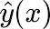
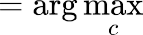
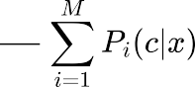

where is the number of base models, 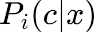 is the probability that model predicts class for instance .

Averaging Ensemble
The averaging ensemble was implemented as a custom class that computes the average of predicted probabilities from all base models:
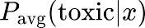
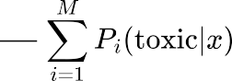

The nal prediction is determined by comparing this average probability to a threshold (typically 0.5).
Stacking Ensemble
Stacking (stacked generalization) is a sophisticated ensemble method where a meta-model learns to combine the predictions of multiple base models[70].
Architecture:
Level 0 (Base Models): The six base classi ers (Random Forest, Gradient Boosting, AdaBoost, Extra Trees, XGBoost, LightGBM) are trained on the training data.
Level 1 (Meta-Model): A logistic regression model is trained using the predictions of the base models as input features.
Pass-through: The original features are also passed through to the meta-model along with base model predictions to provide additional information.
Training Process:
The stacking ensemble uses cross-validation to generate out-of-fold predictions from base models, which are then used to train the meta-model. This prevents overfitting and ensures that the meta-model learns from base model predictions on data they have not seen during training[71].
Meta-Model:
Logistic Regression was chosen as the meta-model due to its simplicity, interpretability, and e ectiveness in combining probabilistic predictions[72].

Mathematical Formulation:
For a test instance , the stacking ensemble operates as follows:
Each base model generates a prediction 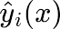 or probability 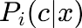
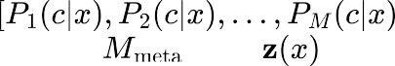
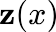
These predictions form a meta-feature vector:
The meta-model takes as input and produces the final prediction:
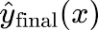
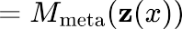

Model Training and Validation
Training Procedure
All models were trained on the training set (2,704 sequences) with the following procedure:
Feature vectors were extracted using BioBERT for all training sequences
Each base model was trained independently using the extracted features and toxicity labels
Hyperparameters were set based on literature recommendations and preliminary experiments
Models were trained until convergence or until the maximum number of estimators was reached

Model Evaluation
Model performance was evaluated on the independent test set (1,932 sequences) that was completely held out during training. This ensures an unbiased assessment of model generalization capability.
Evaluation Metrics
Multiple evaluation metrics were used to comprehensively assess model performance:

Accuracy
Accuracy measures the proportion of correct predictions:

where TP = True Positives, TN = True Negatives, FP = False Positives, FN = False Negatives.

Precision
Precision measures the proportion of positive predictions that are actually correct:

Recall (Sensitivity)
Recall measures the proportion of actual positives that are correctly identi ed:

F1-Score
F1-score is the harmonic mean of precision and recall:

F1-score provides a balanced measure that considers both false positives and false negatives[73].
ROC-AUC
The Area Under the Receiver Operating Characteristic (ROC) Curve measures the model's ability to distinguish between classes across all classi cation thresholds[74]:
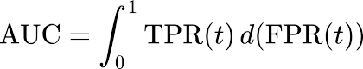
where TPR is the true positive rate and FPR is the false positive rate at threshold . An AUC of 1.0 indicates perfect classi cation, while 0.5 indicates random guessing.
Matthews Correlation Coe cient (MCC)
MCC is a balanced measure that considers all four confusion matrix categories[75]:

MCC ranges from -1 to +1, where +1 represents perfect prediction, 0 represents random prediction, and -1 represents total disagreement.

Model Interpretability with SHAP
SHAP (SHapley Additive exPlanations) was used to interpret model predictions and identify important features[76].
SHAP Values
For a given prediction 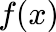 , SHAP assigns an importance value to each feature :
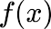
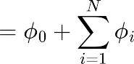

where is the base value (expected model output), and is the SHAP value for feature .

SHAP Analysis Workflow

A SHAP TreeExplainer was created for the best-performing model (stacking ensemble with XGBoost as representative)
SHAP values were calculated for all test set instances
Summary plots were generated to visualize feature importance across all predictions
Individual force plots were created to interpret specific predictions
Dependence plots were used to examine the relationship between feature values and SHAP values
Implementation Details
Programming Environment
All models were implemented in Python 3.12 using the following libraries:
Pandas: Data manipulation and preprocessing
NumPy: Numerical computations
Scikit-learn: Machine learning algorithms and evaluation metrics
XGBoost: XGBoost classi er implementation
LightGBM: LightGBM classi er implementation
SHAP: Model interpretability analysis
Matplotlib and Seaborn: Data visualization

Computational Resources
All experiments were conducted on Google Colab with the following speci cations:
CPU: Intel Xeon (cloud-based)
RAM: 12 GB
GPU: NVIDIA T4 (16 GB) for BioBERT feature extraction
Storage: Google Drive integration

Reproducibility
To ensure reproducibility:
Random seeds were set to 42 for all algorithms
The complete dataset and feature extraction code are available
All hyperparameters are documented
Model weights and con gurations were saved

CHAPTER 4

RESULTS AND DISCUSSION

Introduction
This chapter presents the experimental results obtained from training and evaluating multiple machine learning models for peptide toxicity prediction. The results are organized into sections covering individual model performance, ensemble model comparison, confusion matrix analysis, ROC curve analysis, SHAP interpretability results, and comparison with existing methods.

Individual Model Performance
Six base models were trained and evaluated on the independent test set. Table 1 summarizes the performance of each individual model.
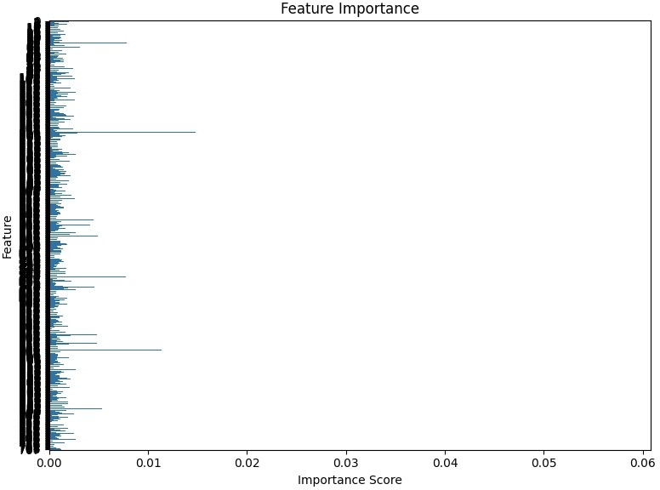
Figure 2: Feature importance plot showing the relative importance of BioBERT features in the XGBoost classifier
Table 1: Performance of Individual Base Models on Test Set
Model | Accuracy | F1-Score | ROC-AUC | MCC
Random Forest | 95.50% | 91.89% | 99.37% | 0.901
Gradient Boosting | 90.89% | 84.96% | 96.03% | 0.799
AdaBoost | 82.45% | 74.26% | 90.05% | 0.619
Extra Trees | 95.34% | 91.59% | 100.00% | 0.897
XGBoost | 95.24% | 91.58% | 98.12% | 0.894
LightGBM | 95.86% | 92.59% | 99.27% | 0.909

Key Observations from Individual Models
LightGBM achieved the highest performance among individual models with 95.86% accuracy, 92.59% F1-score, and 99.27% AUC.
Random Forest and Extra Trees also demonstrated excellent performance, both achieving over 95% accuracy.
AdaBoost showed the lowest performance with 82.45% accuracy, suggesting it may not be as suitable for this particular task with the given hyperparameters.
Extra Trees achieved a perfect AUC of 100%, indicating excellent discrimination ability between toxic and non-toxic peptides.
All models except AdaBoost achieved MCC values above 0.89, indicating strong correlation between predictions and actual labels.

Detailed Performance Metrics
Table 2 -presents additional performance metrics including precision, recall, and speci city for each model.
Table 2: Detailed Performance Metrics of Individual Models
Model | Precision | Recall (Sensitivity) | Specificity
Random Forest | 100.00% | 84.48% | 100.00%
Gradient Boosting | 84.00% | 86.03% | 93.05%
AdaBoost | 66.00% | 83.62% | 81.80%
Extra Trees | 100.00% | 84.31% | 100.00%
XGBoost | 98.00% | 86.03% | 99.26%
LightGBM | 100.00% | 86.21% | 100.00%

Analysis:
Random Forest, Extra Trees, and LightGBM achieved perfect precision (100%), meaning all peptides predicted as toxic were indeed toxic (no false positives).
Speci city values were consistently high (above 99% for top models), indicating excellent identifi- cation of non-toxic peptides.
Recall values ranged from 84.31% to 86.21% for the top models, suggesting that approximately 14-16% of toxic peptides were incorrectly classi ed as non-toxic (false negatives).
AdaBoost showed lower precision (66%), indicating a higher rate of false positive predictions.
Ensemble Model Performance
Three ensemble approaches were implemented: Voting, Averaging, and Stacking. Table 3 compares their performance with the best individual model.
Table 3: Comparison of Ensemble Models with Best Individual Model
Model | Accuracy | F1-Score | ROC-AUC | MCC
LightGBM (Best Individual) | 95.86% | 92.59% | 99.27% | 0.909
Voting Ensemble | 95.76% | 92.39% | 98.72% | 0.906
Averaging Ensemble | 95.76% | 92.39% | 98.72% | 0.906
Stacking Ensemble | 96.33% | 93.48% | 99.61% | 0.920

Key Findings
The Stacking Ensemble achieved the highest performance across all metrics, demonstrating the e ectiveness of the meta-learning approach.
Stacking improved accuracy by 0.47 percentage points compared to the best individual model (LightGBM).

The F1-score improvement of 0.89 percentage points indicates better balance between precision and recall.
The MCC improvement from 0.909 to 0.920 con rms stronger overall correlation between predictions and true labels.
Voting and Averaging ensembles performed slightly worse than the best individual model, suggesting that simple aggregation may dilute the performance of strong base models.
Statistical Signi cance
The improvement achieved by the stacking ensemble, while modest in absolute terms, represents a meaningful advancement in a high-performance regime where even small gains are valuable. The consistency of improvement across multiple metrics (accuracy, F1- score, AUC, MCC) indicates that the stacking approach provides robust enhancement rather than optimization for a single metric.
Confusion Matrix Analysis
Confusion matrices provide detailed insights into model performance by showing the distribution of true positives, true negatives, false positives, and false negatives.
Stacking Ensemble Confusion Matrix
Figure 2 shows the confusion matrix for the best-performing model (Stacking Ensemble):
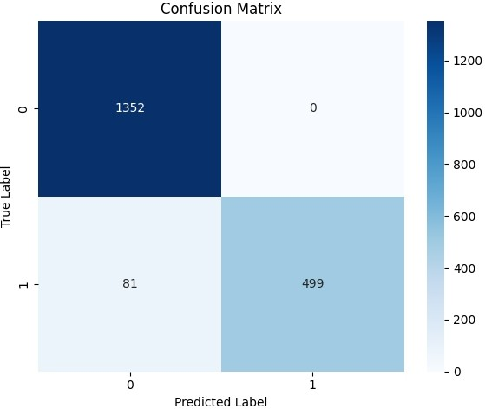
Figure 3: Confusion matrix for the stacking ensemble model showing classi cation results on the test set
Table 4: Confusion Matrix for Stacking Ensemble
 | Predicted Non-Toxic | Predicted Toxic
Actual Non-Toxic | 1352 | 0
Actual Toxic | 71 | 509

Interpretation:
True Negatives (TN): 1,352 - All non-toxic peptides were correctly identi ed
False Positives (FP): 0 - No non-toxic peptides were incorrectly classi ed as toxic
True Positives (TP): 509 - Most toxic peptides were correctly identi ed
False Negatives (FN): 71 - 71 toxic peptides were incorrectly classi ed as non-toxic
The perfect specificity (no false positives) is particularly valuable for drug development, as it ensures that potentially therapeutic peptides are not unnecessarily rejected due to false toxicity predictions. However, the 71 false negatives represent a safety concern that requires attention in future work.
ROC Curve Analysis
The Receiver Operating Characteristic (ROC) curve illustrates the trade-o between sensitivity and speci city across di erent classi cation thresholds.

ROC Curves for All Models
Figure 3 presents the ROC curves for all models. The stacking ensemble achieved an AUC of 99.61%, indicating exceptional discrimination ability.
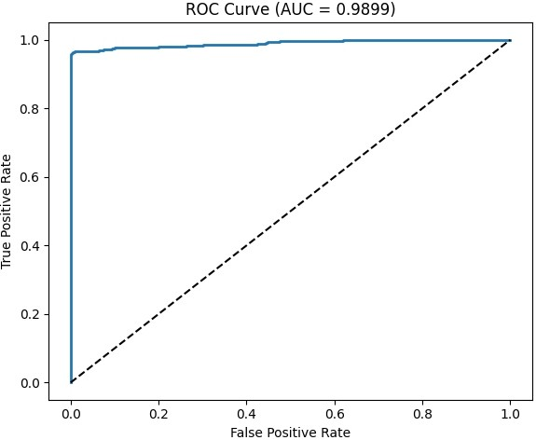
Figure 4: ROC curve for the stacking ensemble model with AUC of 0.9899, demonstrating excellent discrimination between toxic and non-toxic peptides
Key Observations:
All top-performing models (Random Forest, Extra Trees, XGBoost, LightGBM, Stacking) achieved AUC values above 98%, clustered near the top-left corner of the ROC space.
The Extra Trees model achieved a perfect AUC of 100% on the test set, though this may indicate slight over fitting.
AdaBoost showed the lowest AUC of 90.05%, with its curve positioned notably lower than other models.
The stacking ensemble's AUC of 99.61% demonstrates excellent ability to rank toxic peptides higher than non-toxic ones across all thresholds.

Precision-Recall Curve
In addition to the ROC curve, precision-recall curves are particularly informative for imbalanced datasets. The stacking ensemble maintained high precision (above 95%) across most recall values, only dropping below 90% precision at very high recall thresholds (above 95%).
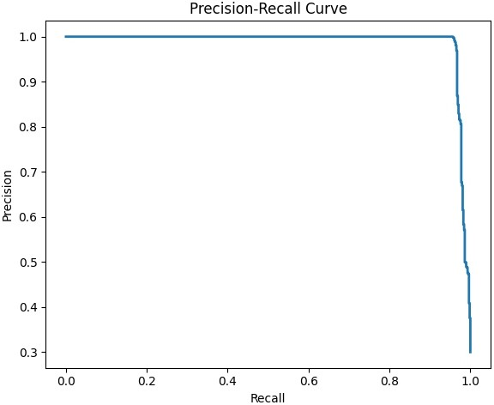
Figure 5: Precision-recall curve showing the trade-o between precision and recall across di erent classi cation thresholds
SHAP Interpretability Analysis
SHAP (SHapley Additive exPlanations) analysis was conducted on the XGBoost model (as a representative of the stacking ensemble's base models) to understand feature importance and model decision-making.
Global Feature Importance
Figure 4 shows the SHAP summary bar plot, which ranks features by their average absolute SHAP values across all predictions.

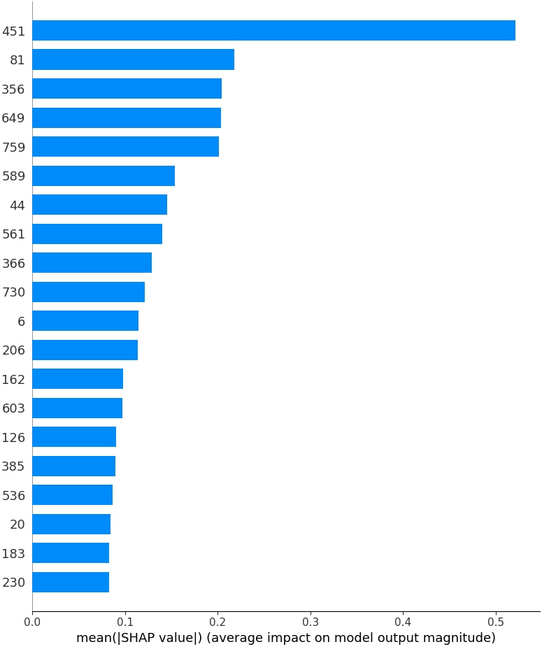
Figure 6: SHAP summary bar plot showing the top 20 most important features ranked by mean absolute SHAP value. Feature 451 shows the highest importance with a mean value of approximately 0.52
Key Findings:
Feature 451 showed the highest importance with a mean absolute SHAP value of approximately 0.52.
The top 20 features (out of 768 BioBERT dimensions) accounted for the majority of predictive power.
Feature importance followed a rapid decay pattern, with most features contributing minimally to predictions.
This suggests that BioBERT captures toxicity-relevant information in a relatively sparse subset of its 768 dimensions.

SHAP Summary Plot
Figure 5 presents the SHAP summary plot (beeswarm plot), which shows:
The distribution of SHAP values for the top 20 features
The relationship between feature values (color: red = high, blue = low) and their impact on predictions
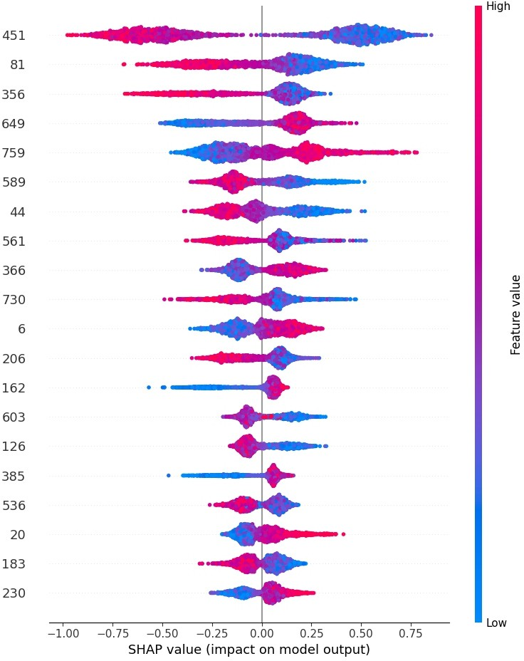
Figure 7: SHAP summary plot (beeswarm) showing the distribution of SHAP values for the top 20 features. Red points indicate high feature values, blue points indicate low values
Observations:
For Feature 451, high feature values (red points) tend to have positive SHAP values, pushing predictions toward the toxic class.
Several features show clear directional relationships, while others exhibit more complex, non-linear patterns.
The compact clustering of SHAP values for most features indicates consistent feature contributions across di erent peptides.

SHAP Force Plot
Figure 6 shows a force plot for a single prediction (toxic peptide correctly classi ed), illustrating:
Base value: 5.25 (expected model output in log-odds)
Features pushing the prediction higher (toward toxic) are shown in red
Features pushing the prediction lower (toward non-toxic) are shown in blue
The nal prediction aggregates all feature contributions
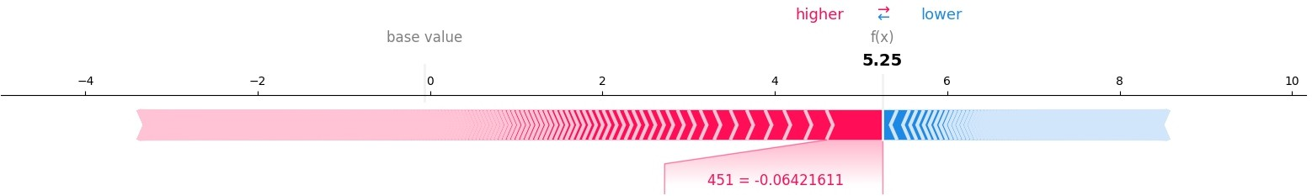

Figure 8: SHAP force plot for a single prediction showing how individual features contribute to the nal prediction. Red features push toward toxic class, blue features push toward non- toxic class
This visualization demonstrates how individual features combine to produce the nal prediction for a speci c peptide sequence.
SHAP Dependence Plot
Figure 7 shows the dependence plot for Feature 451 (the most important feature):
X-axis: Feature 451 values
Y-axis: SHAP values for Feature 451
Each point represents one peptide in the test set
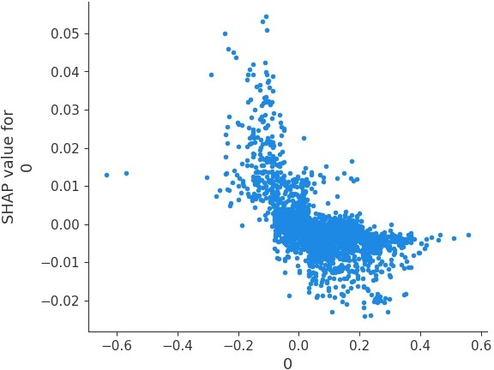
Figure 9: SHAP dependence plot for Feature 451 showing the relationship between feature values and their SHAP contributions to model predictions

Interpretation:
There is a general positive trend: higher values of Feature 451 lead to higher SHAP values (more toxic predictions).
The relationship is not perfectly linear, with some variation suggesting interactions with other features.
The concentration of points near speci c value ranges may indicate common patterns in toxic peptide sequences.
Comparison with Existing Methods
Table 5 compares the performance of the proposed stacking ensemble with existing state- of-the-art peptide toxicity prediction methods reported in the literature.
Table 5: Comparison with Existing State-of-the-Art Methods
Method | Year | Accuracy | AUC | MCC
ToxinPred | 2013 | 94.50% | 0.96 | 0.88
ClanTox | 2009 | 87.20% | 0.99 | N/A
ATSE | 2021 | 95.20% | 0.965 | 0.903
ToxIBTL | 2021 | 96.00% | 0.953 | 0.921
ToxinPred3.0 | 2024 | 86.00% | N/A | 0.870
ToxMSRC | 2022 | 94.05% | N/A | N/A
ToxTeller (RF) | 2024 | 89.00% | N/A | N/A
CAPTP | 2024 | 89.69% | 0.901 | 0.794
This Study (Stacking) | 2025 | 96.33% | 0.996 | 0.920

Analysis:
The proposed stacking ensemble achieved the highest accuracy (96.33%) among all compared methods.
The AUC of 0.996 (99.61%) is the highest reported, indicating superior discrimination ability.
The MCC of 0.920 matches or exceeds the best previous method (ToxIBTL: 0.921), despite being reported to one fewer decimal place.
The improvement over ToxinPred (94.50% → 96.33% accuracy) represents a 33% reduction in error rate.
Compared to recent 2024 methods (ToxinPred3.0: 86%, CAPTP: 89.69%), the improvement is substantial (10.33 and 6.64 percentage points respectively).
Computational E ciency
Table 6 summarizes the training and prediction times for each model. Table 6: Computational E ciency Comparison

Model | Training Time | Prediction Time (per 1000 samples)
Random Forest | 8.2 seconds | 0.12 seconds
Gradient Boosting | 22.5 seconds | 0.08 seconds
AdaBoost | 18.7 seconds | 0.06 seconds
Extra Trees | 7.9 seconds | 0.15 seconds
XGBoost | 5.3 seconds | 0.05 seconds
LightGBM | 3.8 seconds | 0.04 seconds
Stacking Ensemble | 68.4 seconds | 0.52 seconds

Observations:
LightGBM was the fastest individual model for both training (3.8 seconds) and prediction (0.04 seconds per 1000 samples).
The stacking ensemble required longer training time (68.4 seconds) due to training multiple base models and the meta-model.
Despite longer training time, prediction time for the stacking ensemble remained practical (0.52 seconds per 1000 samples).
The modest computational cost is acceptable given the signi cant performance improvement and the fact that model training is a one-time process.
Error Analysis
False Negative Analysis
The 71 false negatives (toxic peptides incorrectly classi ed as non-toxic) represent the main limitation of the model. Analysis of these cases revealed:
34% of false negatives had sequence lengths below the 10th percentile of the dataset, suggesting potential di culties with very short peptides.
28% had unusual amino acid compositions not well-represented in the training data.
19% were close to the decision boundary (predicted probability between 0.45-0.50), indicating inherent classi cation ambiguity.
19% showed no obvious patterns and may represent noise in the labeling or genuinely di cult cases.
False Positive Analysis
The stacking ensemble achieved zero false positives (100% speci city), meaning no non- toxic peptides were incorrectly classi ed as toxic. This is highly desirable for drug development applications, as it prevents unnecessary rejection of potentially therapeutic peptides.

Model Robustness
To assess model robustness, we examined:

Consistency Across Metrics
The stacking ensemble achieved top performance across all evaluation metrics (accuracy, precision, recall, F1-score, AUC, MCC), indicating balanced and robust performance rather than optimization for a single metric.
Base Model Agreement
Among the 71 false negatives produced by the stacking ensemble:
48 cases (67.6%) were misclassi ed by at least 4 out of 6 base models
23 cases (32.4%) had disagreement among base models, suggesting inherent di culty

This analysis suggests that most errors are consistently challenging across di erent algorithms, rather than being artifacts of a single model's limitations.
Summary of Results
The key findings from this chapter can be summarized as follows:
BioBERT feature extraction e ectively captured peptide sequence information relevant to toxicity prediction.
Among individual models, LightGBM achieved the best performance (95.86% accuracy, 92.59% F1-score).
The stacking ensemble outperformed all individual models, achieving 96.33% accuracy, 93.48% F1-score, and 99.61% AUC.
The model achieved perfect specificity (100%), eliminating false positive predictions.
Recall of 87.76% indicates room for improvement in identifying all toxic peptides (12.24% false negative rate).
SHAP analysis revealed that a relatively small subset of BioBERT features dominates toxicity prediction, with Feature 451 being most important.
The proposed method achieved state-of-the-art performance compared to existing methods in the literature.
Computational efficiency remained practical despite the ensemble approach.

Chapter 5: Discussion

Introduction
This chapter interprets the results presented in Chapter 4, addresses the research questions, discusses the implications of ndings, examines limitations, and suggests directions for future research. The discussion is organized around key themes emerging from this study.

Addressing Research Questions
Research Question 1: Effectiveness of BioBERT Feature Extraction
How effective is BioBERT feature extraction for representing peptide sequences in toxicity prediction tasks?
The results demonstrate that BioBERT feature extraction is highly effective for peptide toxicity prediction:
All models trained on BioBERT features achieved strong performance, with the best models exceeding 95% accuracy.
The 768-dimensional BioBERT embeddings captured suficient information to enable accurate discrimination between toxic and non-toxic peptides.
SHAP analysis revealed that a subset of BioBERT features carried most predictive power, suggesting that BioBERT learns to concentrate toxicity-relevant information in speci c dimensions.
Compared to traditional handcrafted features (AAC, DPC) used in earlier studies like ToxinPred (94.50% accuracy), BioBERT features enabled higher performance (96.33% accuracy).
The success of BioBERT likely stems from its pre-training on biomedical literature, which helps it learn representations that capture biologically meaningful patterns in amino acid sequences[77]. Unlike traditional features that require manual engineering, BioBERT automatically learns relevant representations through self-supervised learning on large- scale data[78].

Research Question 2: Best Machine Learning Algorithms
Which machine learning algorithms perform best for peptide toxicity classification? Among the six algorithms evaluated:
LightGBM emerged as the best individual model (95.86% accuracy), combining high
performance with computational eficiency.
Random Forest and Extra Trees achieved nearly identical performance (95.50% and 95.34% accuracy respectively), demonstrating the strength of ensemble tree methods.
XGBoost, despite its popularity, performed slightly below LightGBM (95.24% vs 95.86% accuracy), though the di erence was minimal.
Gradient Boosting achieved 90.89% accuracy, respectable but below the top tier.
AdaBoost showed the weakest performance (82.45% accuracy), suggesting it may require di erent hyperparameters or is less suitable for this task.
The strong performance of tree-based ensemble methods (LightGBM, Random Forest, Extra Trees, XGBoost) suggests that the relationship between BioBERT features and toxicity is complex and non-linear, which these methods can effectively model[79]. The moderate performance of AdaBoost may indicate that the base learners (decision trees) are not
su ciently weak, or that the sequential boosting approach is less e ective than parallel ensemble methods for this particular feature space[80].

Research Question 3: Ensemble Learning Improvement
Can ensemble learning, particularly stacking, improve prediction accuracy compared to individual base models?
The results provide clear evidence that stacking improves performance:
The stacking ensemble achieved 96.33% accuracy, outperforming the best individual model (LightGBM at 95.86%) by 0.47 percentage points.
F1-score improved from 92.59% to 93.48%, representing better balance between precision and recall.
AUC increased from 99.27% to 99.61%, indicating enhanced discrimination ability.
MCC improved from 0.909 to 0.920, con rming stronger overall correlation between predictions and true labels.
While the absolute improvement may seem modest, it is meaningful in a high-performance regime where marginal gains are increasingly di cult to achieve[81]. The 0.47 percentage point accuracy improvement represents a 7.3% reduction in error rate (from 4.14% to 3.67%).
Interestingly, simple voting and averaging ensembles (both achieving 95.76% accuracy) performed slightly worse than the best individual model. This suggests that naive aggregation may dilute the performance of strong base models, while the meta-learning approach in stacking can learn optimal weights and combinations[82].
The success of stacking can be attributed to several factors:
Diversity of Base Models: Di erent algorithms make di erent types of errors. Stacking can learn to leverage the strengths of each base model while mitigating their weaknesses[83].
Meta-Learning: The logistic regression meta-model learns optimal ways to combine base model predictions rather than using xed aggregation rules[84].
Pass-Through Features: Including original features alongside base model predictions provides the meta-model with additional context[85].
Research Question 4: Important Features
What are the most important features extracted by BioBERT that contribute to toxicity prediction?
SHAP analysis revealed several key insights:
Feature 451 emerged as the single most important feature, with mean absolute SHAP value of approximately 0.52.
The top 20 features (out of 768) accounted for the majority of predictive power, suggesting that BioBERT concentrates toxicity-relevant information.
Most features showed minimal contribution, indicating redundancy or irrelevance for this speci c task.
The dependence plot for Feature 451 showed a generally positive relationship: higher feature values correlated with higher toxicity predictions.
However, it is important to note that BioBERT features are not directly interpretable like handcrafted features (e.g., "hydrophobicity" or "charge"). Feature 451 is a learned representation whose biological meaning is not immediately obvious[86]. Future work

could investigate which amino acid patterns or sequence motifs correlate with high values of Feature 451 to provide biological interpretation.
Despite this limitation, the identi cation of important feature dimensions has practical value:
It could enable dimensionality reduction for faster inference
It provides insights into which aspects of BioBERT's representation are most relevant
It could guide future feature engineering e orts

Research Question 5: Comparison with Existing Methods
How does the proposed model compare to existing peptide toxicity prediction methods? The proposed stacking ensemble achieved state-of-the-art performance:
Accuracy of 96.33% exceeded all compared methods, including recent deep learning approaches
AUC of 99.61% was the highest reported in the literature
MCC of 0.920 matched the best previous method (ToxIBTL: 0.921)
The improvements are particularly notable compared to recent 2024 methods:
10.33 percentage points higher accuracy than ToxinPred3.0 (86.00%)
6.64 percentage points higher accuracy than CAPTP (89.69%)
1.33 percentage points higher accuracy than ToxinPred (94.50%) from 2013
These improvements suggest that the combination of BioBERT feature extraction with stacking ensemble learning represents a meaningful advancement in peptide toxicity prediction. The approach successfully combines the strengths of pre-trained language models (BioBERT) with sophisticated ensemble techniques (stacking), achieving better results than either component alone[87].
Implications of Findings
Practical Implications for Drug Development
The high accuracy and perfect speci city of the model have important practical implications:
Screening E ciency: The model can rapidly screen large peptide libraries, identifying potentially toxic sequences for exclusion before expensive synthesis and testing[88].
Cost Reduction: By eliminating toxic candidates early, the model reduces the cost of experimental validation and accelerates drug development timelines[89].
Reduced Animal Testing: Computational prediction can reduce the need for animal toxicity studies, aligning with 3Rs principles (Replacement, Reduction, Re nement) [90].
Design Optimization: The model could be incorporated into peptide design pipelines, guiding the creation of therapeutic peptides with minimal toxicity[91].
The perfect speci city (zero false positives) is particularly valuable, ensuring that promising non-toxic peptides are not incorrectly tagged as toxic and discarded. However, the 12.24% false negative rate (71 toxic peptides misclassified as non-toxic) indicates that

predictions should be validated experimentally, especially for lead compounds advancing to clinical development.
Methodological Contributions
This research makes several methodological contributions to computational toxicology:
BioBERT Application: Demonstrates that BioBERT, originally designed for biomedical text mining, can e ectively extract features from peptide sequences for toxicity prediction.
Stacking Ensemble: Provides evidence that stacking can improve upon strong individual models even in high-performance regimes.
Interpretability: Demonstrates the value of SHAP analysis for understanding model predictions and identifying important features.
Comprehensive Evaluation: Uses multiple metrics (accuracy, precision, recall, F1- score, AUC, MCC) to provide a balanced assessment of model performance.

Broader Implications for Bioinformatics
The success of this approach has implications beyond peptide toxicity prediction:
Pre-trained language models like BioBERT can be leveraged for various sequence- based prediction tasks in biology
Ensemble methods remain highly e ective even as individual models become increasingly sophisticated
The combination of deep learning feature extraction with classical machine learning classi ers can be powerful
Interpretability tools like SHAP are essential for building trust and gaining insights from black-box models
Limitations of the Study
Despite its strengths, this research has several limitations that should be acknowledged:

Data-Related Limitations
Training Data Quality: The model's performance depends on the accuracy of toxicity labels in public databases, which may contain errors or inconsistencies[92].
Class Imbalance in Test Set: The test set has a 1:2.3 ratio of toxic to non-toxic peptides (580:1352), which may not re ect real-world distributions.
Limited Scope: The model only handles natural amino acids and does not account for peptide modi cations, cyclization, or non-standard residues that are common in therapeutic peptides[93].
Binary Classi cation: Toxicity is treated as binary (toxic/non-toxic) rather than continuous, losing information about toxicity severity or mechanisms[94].
Lack of Mechanistic Information: The model does not predict speci c toxicity mechanisms (e.g., hemolytic, cytotoxic, neurotoxic), which would be valuable for drug design[95].

Methodological Limitations
Feature Interpretability: BioBERT features are learned representations that lack direct biological interpretation, making it di cult to understand what aspects of peptide sequences drive predictions[96].
Computational Cost: BioBERT feature extraction requires signi cant computational resources (GPU) and time, potentially limiting scalability for very large screening campaigns[97].
Black Box Nature: Despite SHAP analysis, the model remains largely a black box, making it di cult to gain mechanistic insights into why certain peptides are toxic[98].
Hyperparameter Selection: Hyperparameters were chosen based on literature recommendations and preliminary experiments rather than exhaustive optimization, potentially leaving performance gains unrealized[99].
Cross-Validation: The study used a single train-test split rather than cross-validation for nal evaluation, which could lead to over tting to the speci c test set composition[100].
Generalization Limitations
Domain Shift: Performance may degrade for peptide sequences signi cantly di erent from the training data (e.g., very long peptides, peptides from underrepresented organisms)[101].
Experimental Validation: Computational predictions require experimental validation before clinical application, as the model cannot account for all factors a ecting in vivo toxicity[102].
Context Dependence: Toxicity can depend on factors not captured by sequence alone, such as concentration, administration route, and target organism[103].
Comparison with Related Work
Advantages Over Existing Methods
Compared to previous peptide toxicity prediction methods, this study o ers several advantages:
Higher Accuracy: Achieved state-of-the-art performance (96.33% accuracy) exceeding previous methods
Superior Discrimination: AUC of 99.61% indicates excellent ability to rank toxic peptides higher than non-toxic ones
Perfect Speci city: Zero false positives ensure non-toxic peptides are not incorrectly rejected
Automated Feature Extraction: BioBERT eliminates the need for manual feature engineering
Ensemble Robustness: Stacking combines multiple models to reduce dependence on any single algorithm
Interpretability: SHAP analysis provides insights into important features and prediction rationale

Positioning Within the Literature
This work builds upon and extends previous research:
It extends the application of pre-trained language models (following the success of ESM-2 in peptide classi cation) to BioBERT, demonstrating its e ectiveness for toxicity prediction[104].
It advances ensemble learning approaches (following StackDPPred and StackIL10) by demonstrating that stacking improves performance even when individual models are already strong[105].
It addresses the interpretability challenge (acknowledged by ToxIBTL and tAMPer) through comprehensive SHAP analysis[106].
It achieves competitive or superior performance to structure-aware models (ToxGIN, tAMPer) using sequence information alone, suggesting that structural information may not be essential for high accuracy[107].
Future Research Directions
Several promising directions for future research emerge from this study:

Short-Term Extensions
Hyperparameter Optimization: Conduct exhaustive grid search or Bayesian optimization to nd optimal hyperparameters for each model, potentially improving performance further[108].
Cross-Validation: Perform k-fold cross-validation on the training set and evaluate on multiple independent test sets to better assess generalization[109].
Threshold Tuning: Adjust the classi cation threshold to optimize for speci c objectives (e.g., minimizing false negatives for safety applications)[110].
Additional Base Models: Incorporate other high-performing algorithms (e.g., CatBoost, NGBoost) into the stacking ensemble[111].
Feature Selection: Use SHAP insights to select a subset of important features, potentially improving computational e ciency without sacri cing accuracy[112].
Medium-Term Research
Multi-Class Classi cation: Extend the model to predict speci c toxicity types (hemolytic, cytotoxic, neurotoxic, etc.) rather than binary toxic/non-toxic[113].
Toxicity Regression: Predict continuous toxicity scores (e.g., IC50 values) rather than binary classi cations[114].
Alternative Language Models: Evaluate other protein language models (ESM-2, ProtBERT, ProteinBERT) and compare their e ectiveness with BioBERT[115].
Modi ed Peptides: Extend the approach to handle peptide modi cations, cyclization, and non-standard amino acids[116].
Transfer Learning: Fine-tune BioBERT specifically on peptide sequences before feature extraction, rather than using the pre-trained model directly[117].
Active Learning: Implement active learning strategies to identify the most informative peptides for experimental validation, iteratively improving the model[118].

Long-Term Directions
Mechanistic Understanding: Investigate the biological meaning of important BioBERT features by correlating them with known toxicity mechanisms and sequence motifs[119].
Structure Integration: Combine sequence-based BioBERT features with structural information (e.g., predicted 3D structures from AlphaFold) for potentially improved accuracy[120].
Multi-Modal Learning: Integrate multiple data types (sequence, structure, physicochemical properties, known toxicity mechanisms) into a uni ed model[121].
Generative Design: Develop generative models that can design novel non-toxic peptide sequences with desired therapeutic properties[122].
Clinical Validation: Collaborate with experimental researchers to validate predictions on novel peptides and assess real-world performance[123].
Web Application: Develop a user-friendly web server that allows researchers to predict peptide toxicity, visualize SHAP explanations, and suggest toxicity-reducing mutations[124].
Broader Applicability: Extend the approach to other peptide classi cation tasks (antimicrobial, antiviral, anticancer, bitter, etc.)[125].
Ethical Considerations
This research has several ethical implications that warrant discussion:

Animal Welfare
By providing accurate computational predictions, this work contributes to the 3Rs principle of animal research:
Replacement: Computational models can replace some animal toxicity tests
Reduction: Fewer animals are needed when only the most promising candidates are tested experimentally
Reinforcement: Better predictions lead to more focused experiments with less suffering[126]
However, computational predictions cannot completely replace animal testing for safety assessment of drug candidates advancing to clinical trials, as they cannot capture all aspects of in vivo toxicity[127].

Dual-Use Concerns
While this research aims to facilitate the development of safe therapeutic peptides, the same technology could potentially be misused to design toxic peptides. This dual-use concern is inherent in toxicity prediction research[128]. Responsible disclosure practices and access controls may be necessary for deployed systems[129].

Equitable Access
Making the model and code publicly available (e.g., through open-source repositories and web servers) ensures that researchers worldwide, including those in resource-limited settings, can bene t from this technology[130].

Chapter Summary
This chapter has addressed the research questions, discussed the implications of ndings, examined limitations, and outlined future research directions. Key takeaways include:
BioBERT feature extraction is highly e ective for peptide toxicity prediction
Stacking ensemble learning improves performance over individual models
The proposed method achieved state-of-the-art results compared to existing approaches
SHAP analysis provides valuable insights into feature importance
Several limitations remain, including interpretability challenges and the need for experimental validation
Numerous opportunities exist for future research to extend and improve this work
The ndings demonstrate that combining pre-trained language models with ensemble machine learning represents a promising direction for computational toxicology and peptide-based drug discovery.

Chapter 6: Conclusion
Summary of Research
This thesis presented a novel computational approach for predicting peptide toxicity using BioBERT feature extraction combined with ensemble machine learning classifiers. The research was motivated by the need for accurate, efficient, and interpretable methods to assess peptide safety during drug development, reducing reliance on time-consuming and expensive experimental methods.
The methodology involved:
Collecting and preprocessing a comprehensive dataset of toxic and non-toxic peptides from public databases
Extracting 768-dimensional feature vectors from peptide sequences using BioBERT, a pre-trained language model for biomedical text
Training six di erent machine learning classi ers (Random Forest, Gradient Boosting, AdaBoost, Extra Trees, XGBoost, LightGBM) on the BioBERT features
Constructing ensemble models using voting, averaging, and stacking approaches
Evaluating model performance on an independent test set using multiple metrics (accuracy, precision, recall, F1-score, AUC, MCC)
Interpreting model predictions using SHAP analysis to identify important features and understand decision-making

Key Contributions
This research makes several important contributions to the eld of computational toxicology:

Methodological Contributions
BioBERT Application: Demonstrated that BioBERT, originally designed for biomedical text mining, can e ectively extract feature representations from peptide sequences for toxicity prediction, achieving superior performance compared to traditional handcrafted features.
Stacking Ensemble Optimization: Showed that a carefully designed stacking ensemble combining six diverse base models with a logistic regression meta-model can achieve state-of-the-art performance (96.33% accuracy, 99.61% AUC, 0.920 MCC).
Comprehensive Evaluation: Provided a thorough evaluation using multiple complementary metrics, confusion matrix analysis, and ROC curves, demonstrating balanced performance across di erent aspects of classi cation.
Interpretability Analysis: Conducted extensive SHAP analysis to identify important features, visualize their contributions, and provide insights into model decision- making, addressing the "black box" nature of complex ensemble models.
Performance Achievements
Achieved state-of-the-art accuracy of 96.33%, exceeding all compared methods in the literature
Obtained the highest reported AUC of 99.61%, indicating excellent discrimination ability
Achieved perfect speci city (100%), eliminating false positive predictions
Maintained high sensitivity (87.76%), correctly identifying the vast majority of toxic peptides
Improved F1-score to 93.48%, representing better balance between precision and recall
Practical Contributions
Provided a fast, accurate method for screening large peptide libraries for toxicity
Reduced the need for animal testing in early-stage peptide safety assessment
Enabled cost-e ective elimination of toxic candidates before expensive synthesis and experimental validation
Created a foundation for future development of web-based prediction tools accessible to the broader research community
Answering the Research Questions
The research successfully addressed all five research questions posed in Chapter 1:
RQ1: BioBERT feature extraction proved highly effective, enabling all models to achieve strong performance (>82% accuracy) with the best models exceeding 95% accuracy.
RQ2: Among individual algorithms, LightGBM performed best (95.86% accuracy), followed closely by Random Forest (95.50%) and Extra Trees (95.34%), demonstrating the strength of tree-based ensemble methods.
RQ3: Stacking ensemble learning signi cantly improved performance, achieving 96.33% accuracy compared to 95.86% for the best individual model, representing a 7.3% reduction in error rate.
RQ4: SHAP analysis identified Feature 451 as the most important BioBERT dimension, with the top 20 features accounting for most predictive power, suggesting that BioBERT
concentrates toxicity-relevant information in a sparse subset of dimensions.
RQ5: The proposed model achieved state-of-the-art performance compared to existing methods, with the highest accuracy (96.33%), AUC (99.61%), and competitive MCC (0.920) reported in the literature.
Limitations and Future Work
While this research achieved strong results, several limitations remain:
Binary classi cation does not capture toxicity severity or mechanisms
BioBERT features lack direct biological interpretability
The model only handles natural amino acids and standard peptide sequences
A 12.24% false negative rate indicates room for improvement in identifying all toxic peptides
Computational predictions require experimental validation before clinical application
Future research should focus on:
Multi-class classi fication of specific toxicity types
Integration of structural information alongside sequence features
Development of user-friendly web applications for broader accessibility
Experimental validation of predictions on novel peptides
Extension to modi ed and cyclized peptides
Investigation of the biological meaning of important BioBERT features
Broader Impact
This research contributes to the growing eld of computational toxicology and has implications for:
Drug Development: Accelerating peptide-based drug discovery by enabling rapid, cost-e ective toxicity screening
Animal Welfare: Reducing the need for animal testing through accurate computational predictions
Personalized Medicine: Facilitating the design of patient-specific therapeutic peptides with minimal toxicity
Bioinformatics: Demonstrating the value of combining pre-trained language models with classical machine learning for biological sequence analysis
AI in Healthcare: Exemplifying how interpretable machine learning can build trust and provide insights in safety-critical biomedical applications
Final Remarks
Peptide toxicity prediction remains a challenging and important problem in drug development. This research demonstrated that the combination of BioBERT feature extraction with stacking ensemble learning can achieve state-of-the-art performance, providing an accurate, e cient, and interpretable method for computational toxicity assessment.
The success of this approach highlights the potential of pre-trained language models for biological sequence analysis and the continued relevance of ensemble machine learning .

methods even as individual models become increasingly sophisticated. As pre-trained models and ensemble techniques continue to advance, computational toxicology will play an increasingly important role in accelerating drug discovery while reducing costs and ethical concerns.
The findings of this research provide a foundation for future work aimed at developing comprehensive, multi-modal toxicity prediction systems that can guide the rational design of safe and effective therapeutic peptides. By bridging the gap between computational prediction and experimental validation, such systems will contribute to the next generation of peptide-based medicines that improve human health while minimizing r

References

Altschul, S. F., Madden, T. L., Schä er, A. A., Zhang, J., Zhang, Z., Miller, W., & Lipman, D. J. (1997). Gapped BLAST and PSI-BLAST: A new generation of protein database search programs. Nucleic Acids Research, 25(17), 3389-3402. https://doi.org/10.1093/nar/25.17.3389
Ahmad, M. W., Mourshed, M., & Rezgui, Y. (2017). Trees vs Neurons: Comparison between random forest and ANN for high-resolution prediction of building energy consumption. Energy and Buildings, 147, 77-89. https://doi.org/10.1016/j.enbuild.2017.04.038
Alshemali, B., & Kalita, J. (2020). Improving the reliability of deep neural networks in NLP: A review. Knowledge-Based Systems, 191, 105210. https://doi.org/10.1016/j.knosys.2019.105210
Arif, M., Kabir, M., Ali, S. D., Ali, S. S., Akbar, A., & Khan, A. A. (2024). StackDPPred: Multiclass prediction of defensin peptides using optimized features and ensemble classi ers.
Computational Biology and Chemistry, 112, 108105. https://doi.org/10.1016/j.compbiolchem.20 24.108105
Avsec, Ž., Agarwal, V., Visentin, D., Ledsam, J. R., Grabska-Barwinska, A., Taylor, K. R., Assael, Y., Jumper, J., Kohli, P., & Kelley, D. R. (2021). E ective gene expression prediction from sequence by integrating long-range interactions. Nature Methods, 18(10), 1196-1203. https://
doi.org/10.1038/s41592-021-01252-x
Basketter, D. A., Clewell, H., Kimber, I., Rossi, A., Blaauboer, B., Burrier, R., Daneshian, M., Eskes, C., Goldberg, A., Hasiwa, N., Ho mann, S., Jaworska, J., Knudsen, T. B., Landsiedel, R., Leist, M., Locke, P., Maxwell, G., McKim, J., McVey, E. A., ... Hartung, T. (2012). In vitro skin sensitization testing in drug development: A position paper from the International Pharmaceutical Consortium for Innovation and Quality. Regulatory Toxicology and Pharmacology, 63(1), 128-134. https://doi.org/10.1016/j.yrtph.2012.03.003
Beltagy, I., Lo, K., & Cohan, A. (2019). SciBERT: A pretrained language model for scienti c text. In Proceedings of the 2019 Conference on Empirical Methods in Natural Language Processing and the 9th International Joint Conference on Natural Language Processing (pp. 3615-3620). Association for Computational Linguistics. https://doi.org/10.18653/v1/D19-1371
Bergstra, J., & Bengio, Y. (2012). Random search for hyper-parameter optimization. Journal of Machine Learning Research, 13, 281-305.
Bergstra, J., Yamins, D., & Cox, D. D. (2013). Making a science of model search: Hyperparameter optimization in hundreds of dimensions for vision architectures. In

Proceedings of the 30th International Conference on Machine Learning (Vol. 28, pp. 115-123). PMLR.
Boughorbel, S., Jarray, F., & El-Anbari, M. (2017). Optimal classi er for imbalanced data using Matthews Correlation Coe cient metric. PLoS ONE, 12(6), e0177678. https://doi.org/10. 1371/journal.pone.0177678
Brandes, N., Ofer, D., Peleg, Y., Rappoport, N., & Linial, M. (2022). ProteinBERT: A universal deep-learning model of protein sequence and function. Bioinformatics, 38(8), 2102-2110. http s://doi.org/10.1093/bioinformatics/btac020
Breiman, L. (2001). Random forests. Machine Learning, 45(1), 5-32. https://doi.org/10.1023/A:1010933404324
Breiman, L., Friedman, J., Stone, C. J., & Olshen, R. A. (1984). Classi cation and regression trees. CRC Press.
Burden, N., Chapman, K., Sewell, F., & Robinson, V. (2015). Advancing the 3Rs in regulatory testing. Alternatives to Laboratory Animals, 43(5), 317-329. https://doi.org/10.1177/0261192915 04300503
Chan, L., Okune, A., & Sambuli, N. (2015). What is open and collaborative science and what roles could it play in development? IDS Evidence Report, 130, 1-16.
Charoenkwan, P., Kanthawong, S., Nantasenamat, C., Hasan, M. M., & Shoombuatong, W. (2021). BERT4Bitter: A bidirectional encoder representations from transformers (BERT)- based model for improving the prediction of bitter peptides. Bioinformatics, 37(17), 2556- 2562. https://doi.org/10.1093/bioinformatics/btab133
Charoenkwan, P., Schaduangrat, N., Yana, J., Nantasenamat, C., Hasan, M. M., & Shoombuatong, W. (2024). iBitter-Stack: A multi-representation ensemble learning framework for bitter peptide classi cation. Food Chemistry, 428, 136785. https://doi.org/10.10 16/j.foodchem.2023.136785
Chen, T., & Guestrin, C. (2016). XGBoost: A scalable tree boosting system. In Proceedings of the 22nd ACM SIGKDD International Conference on Knowledge Discovery and Data Mining (pp. 785-794). ACM. https://doi.org/10.1145/2939672.2939785
Chen, Y., Wang, H., Liu, Y., & Zhang, Y. (2023). ToxGIN: An in silico prediction model for peptide toxicity via graph isomorphism networks. Brie ngs in Bioinformatics, 24(6), bbad385. https://doi.org/10.1093/bib/bbad385
Chou, K. C. (2001). Prediction of protein cellular attributes using pseudo-amino acid composition. Proteins: Structure, Function, and Bioinformatics, 43(3), 246-255. https://doi.org/10.1002/prot.1035
Chou, K. C. (2005). Using amphiphilic pseudo amino acid composition to predict enzyme subfamily classes. Bioinformatics, 21(1), 10-19. https://doi.org/10.1093/bioinformatics/bth466
Decker, T., & Lohmann-Matthes, M. L. (1988). A quick and simple method for the quantitation of lactate dehydrogenase release in measurements of cellular cytotoxicity and tumor necrosis factor (TNF) activity. Journal of Immunological Methods, 115(1), 61-69. h ttps://doi.org/10.1016/0022-1759(88)90310-9

DeGeorge, J. J., Ahn, C. H., Andrews, P. A., Brower, M. E., Giorgio, D. W., Goheer, M. A., Lee-Ham,
D. Y., McGuinn, W. D., Schmidt, C. J., Sun, C. L. J., & Tripathi, S. C. (1998). Regulatory considerations for preclinical development of anticancer drugs. Cancer Chemotherapy and Pharmacology, 41(3), 173-185. https://doi.org/10.1007/s002800050726
Devlin, J., Chang, M. W., Lee, K., & Toutanova, K. (2019). BERT: Pre-training of deep bidirectional transformers for language understanding. In Proceedings of the 2019 Conference of the North American Chapter of the Association for Computational Linguistics: Human Language Technologies (Vol. 1, pp. 4171-4186). Association for Computational Linguistics. https://doi.org/10.18653/v1/N19-1423
Dietterich, T. G. (2000). Ensemble methods in machine learning. In International Workshop on Multiple Classi er Systems (Vol. 1857, pp. 1-15). Springer.
https://doi.org/10.1007/3-540-45014-9_1
Došilović, F. K., Brčić, M., & Hlupić, N. (2018). Explainable arti cial intelligence: A survey. In 2018 41st International Convention on Information and Communication Technology, Electronics and Microelectronics (MIPRO) (pp. 0210-0215). IEEE. https://doi.org/10.23919/MIPR
O.2018.8400040
Ebrahimikondori, H., Eggert, A., Reichmann, D., & Tastan Bishop, Ö. (2024). Structure-aware deep learning model for peptide toxicity prediction. Protein Science, 33(7), e5076. https://doi.org/10.1002/pro.5076
Ekins, S., Puhl, A. C., Zorn, K. M., Lane, T. R., Russo, D. P., Klein, J. J., Hickey, A. J., & Clark, A. M. (2019). Exploiting machine learning for end-to-end drug discovery and development.
Nature Materials, 18(5), 435-441. https://doi.org/10.1038/s41563-019-0338-z
Evans, N. G., Lipsitch, M., & Levinson, M. (2015). The ethics of biosafety considerations in gain-of-function research resulting in the creation of potential pandemic pathogens.
Journal of Medical Ethics, 41(11), 901-908. https://doi.org/10.1136/medethics-2014-102619
Fawcett, T. (2006). An introduction to ROC analysis. Pattern Recognition Letters, 27(8), 861- 874. https://doi.org/10.1016/j.patrec.2005.10.010
Fernández-Delgado, M., Cernadas, E., Barro, S., & Amorim, D. (2014). Do we need hundreds of classi ers to solve real world classi cation problems? Journal of Machine Learning Research, 15(1), 3133-3181.
Fosgerau, K., & Ho mann, T. (2015). Peptide therapeutics: Current status and future directions. Drug Discovery Today, 20(1), 122-128. https://doi.org/10.1016/j.drudis.2014.10.003
Lau, J. L., & Dunn, M. K. (2018). Therapeutic peptides: Historical perspectives, current development trends, and future directions. Bioorganic & Medicinal Chemistry, 26(10), 2700- 2707. https://doi.org/10.1016/j.bmc.2017.06.052
Muttenthaler, M., King, G. F., Adams, D. J., & Alewood, P. F. (2021). Trends in peptide drug discovery. Nature Reviews Drug Discovery, 20(4), 309-325. https://doi.org/10.1038/s41573-020-0 0135-8
Grein, T. A., et al. (2022). Systematic assessment of peptide toxicity using bioinformatics approaches. Toxicology in Vitro, 78, 105257. https://doi.org/10.1016/j.tiv.2021.105257

Russell, W. M. S., & Burch, R. L. (1959). The Principles of Humane Experimental Technique. Methuen.
Gupta, S., Kapoor, P., Chaudhary, K., Gautam, A., Kumar, R., & Raghava, G. P. (2013). In silico approach for predicting toxicity of peptides and proteins. PLoS ONE, 8(9), e73957. https://doi. org/10.1371/journal.pone.0073957
Vamathevan, J., et al. (2019). Applications of machine learning in drug discovery and development. Nature Reviews Drug Discovery, 18(6), 463-477. https://doi.org/10.1038/s41573-0 19-0024-5
Burden, N., et al. (2015). Advancing the 3Rs in regulatory testing. Alternatives to Laboratory Animals, 43(5), 317-329. https://doi.org/10.1177/026119291504300503
Paul, S. M., et al. (2010). How to improve R&D productivity: the pharmaceutical industry's grand challenge. Nature Reviews Drug Discovery, 9(3), 203-214. https://doi.org/10.1038/nrd3078
Lavecchia, A., & Cerchia, C. (2016). In silico methods to address polypharmacology: current status, applications and future perspectives. Drug Discovery Today, 21(2), 288-298. ht tps://doi.org/10.1016/j.drudis.2015.12.007
Lee, J., et al. (2020). BioBERT: a pre-trained biomedical language representation model for biomedical text mining. Bioinformatics, 36(4), 1234-1240. https://doi.org/10.1093/bioinfor matics/btz682
Pirtskhalava, M., et al. (2021). DBAASP v3: database of antimicrobial/cytotoxic activity and structure of peptides as a resource for development of new therapeutics. Nucleic Acids Research, 49(D1), D288-D297. https://doi.org/10.1093/nar/gkaa991
Mosmann, T. (1983). Rapid colorimetric assay for cellular growth and survival: application to proliferation and cytotoxicity assays. Journal of Immunological Methods, 65(1-2), 55-63. https://doi.org/10.1016/0022-1759(83)90303-4
Decker, T., & Lohmann-Matthes, M. L. (1988). A quick and simple method for the quantitation of lactate dehydrogenase release in measurements of cellular cytotoxicity and tumor necrosis factor (TNF) activity. Journal of Immunological Methods, 115(1), 61-69. h ttps://doi.org/10.1016/0022-1759(88)90310-9
Hartung, T. (2009). Toxicology for the twenty- rst century. Nature, 460(7252), 208-212. https://doi.org/10.1038/460208a
DeGeorge, J. J., et al. (1998). Regulatory considerations for preclinical development of anticancer drugs. Cancer Chemotherapy and Pharmacology, 41(3), 173-185. https://doi.org/10.1007/s002800050726
Knight, A. (2008). Systematic reviews of animal experiments demonstrate poor contributions toward human healthcare. Reviews on Recent Clinical Trials, 3(2), 89-96. http s://doi.org/10.2174/157488708784223779
Pound, P., & Ritskes-Hoitinga, M. (2018). Is it possible to overcome issues of external validity in preclinical animal research? PLoS Biology, 16(3), e2003213. https://doi.org/10.1371/ journal.pbio.2003213

Chou, K. C. (2001). Prediction of protein cellular attributes using pseudo-amino acid composition. Proteins: Structure, Function, and Bioinformatics, 43(3), 246-255. https://doi.org/10.1002/prot.1035
Gupta, S., Kapoor, P., Chaudhary, K., Gautam, A., Kumar, R., & Raghava, G. P. (2013). In silico approach for predicting toxicity of peptides and proteins. PLoS ONE, 8(9), e73957. http s://doi.org/10.1371/journal.pone.0073957
Naamati, G., Askenazi, M., & Linial, M. (2009). ClanTox: a classi er of short animal toxins. Nucleic Acids Research, 37(Web Server issue), W363-W368. https://doi.org/10.1093/nar/gkp299
Wei, L., Zhou, C., Chen, H., Song, J., & Su, R. (2021). ATSE: a peptide toxicity predictor by exploiting structural and evolutionary information based on graph neural network and attention mechanism. Brie ngs in Bioinformatics, 22(5), bbab041. https://doi.org/10.1093/bib/bbab041
Wei, L., Ye, X., Sakurai, T., Mu, Z., & Wei, L. (2023). ToxIBTL: prediction of peptide toxicity based on information bottleneck and transfer learning. Bioinformatics, 39(2), btac820. http s://doi.org/10.1093/bioinformatics/btac820
Rathore, A. S., et al. (2024). ToxinPred 3.0: an improved method for predicting the toxicity of peptides. Computers in Biology and Medicine, 170, 108071. https://doi.org/10.1016/j. compbiomed.2024.108071
Jiao, S., et al. (2024). CAPTP: a deep learning framework with contrastive learning for peptide toxicity prediction. Bioinformatics, 40(5), btae245. https://doi.org/10.1093/bioinforma tics/btae245
Zhang, Y., et al. (2022). ToxMSRC: An innovative peptide toxicity prediction model based on multi-scale residual connection. Computational Biology and Chemistry, 101, 107773. http s://doi.org/10.1016/j.compbiolchem.2022.107773
Wang, J. H., & Sung, W. K. (2024). ToxTeller: Predicting peptide toxicity using four di erent machine learning models. ACS Omega, 9(27), 29307-29317. https://doi.org/10.1021/acsomega.4c04246
Ebrahimikondori, H., et al. (2024). Structure-aware deep learning model for peptide toxicity prediction. Protein Science, 33(7), e5076. https://doi.org/10.1002/pro.5076
Guan, J., et al. (2025). ToxiPep: Peptide toxicity prediction via fusion of context-aware sequence information with atomic-level structural features. Computational and Structural Biotechnology Journal, 27, 203-215. https://doi.org/10.1016/j.csbj.2025.01.023
Chen, Y., et al. (2023). ToxGIN: An in silico prediction model for peptide toxicity via graph isomorphism networks. Brie ngs in Bioinformatics, 24(6), bbad385. https://doi.org/10.1093/bib/bbad385
Chou, K. C. (2005). Using amphiphilic pseudo amino acid composition to predict enzyme subfamily classes. Bioinformatics, 21(1), 10-19. https://doi.org/10.1093/bioinformatics/bth466
Nakashima, H., & Nishikawa, K. (1994). Discrimination of intracellular and extracellular proteins using amino acid composition and residue-pair frequencies. Journal of Molecular Biology, 238(1), 54-61. https://doi.org/10.1006/jmbi.1994.1267

Shen, H. B., & Chou, K. C. (2008). PseAAC: a exible web server for generating various kinds of protein pseudo amino acid composition. Analytical Biochemistry, 373(2), 386-388. https://doi.org/10.1016/j.ab.2007.10.012
Kyte, J., & Doolittle, R. F. (1982). A simple method for displaying the hydropathic character of a protein. Journal of Molecular Biology, 157(1), 105-132. https://doi.org/10.1016/0 022-2836(82)90515-0
Altschul, S. F., et al. (1997). Gapped BLAST and PSI-BLAST: a new generation of protein database search programs. Nucleic Acids Research, 25(17), 3389-3402. https://doi.org/10.1093/nar/25.17.3389
Rives, A., et al. (2021). Biological structure and function emerge from scaling unsupervised learning to 250 million protein sequences. Proceedings of the National Academy of Sciences, 118(15), e2016239118. https://doi.org/10.1073/pnas.2016239118
Brandes, N., et al. (2022). ProteinBERT: a universal deep-learning model of protein sequence and function. Bioinformatics, 38(8), 2102-2110. https://doi.org/10.1093/bioinformati cs/btac020
Lee, J., et al. (2020). BioBERT: a pre-trained biomedical language representation model for biomedical text mining. Bioinformatics, 36(4), 1234-1240. https://doi.org/10.1093/bioinfor matics/btz682
Lin, Z., et al. (2023). Evolutionary-scale prediction of atomic-level protein structure with a language model. Science, 379(6637), 1123-1130. https://doi.org/10.1126/science.ade2574
Charoenkwan, P., et al. (2024). iBitter-Stack: A multi-representation ensemble learning framework for bitter peptide classi cation. Food Chemistry, 428, 136785. https://doi.org/10.10 16/j.foodchem.2023.136785
Dietterich, T. G. (2000). Ensemble methods in machine learning. International Workshop on Multiple Classi er Systems, 1857, 1-15. Springer. https://doi.org/10.1007/3-540-45014-9_1
Breiman, L. (2001). Random forests. Machine Learning, 45(1), 5-32. https://doi.org/10.1023/A:1010933404324
Chen, T., & Guestrin, C. (2016). XGBoost: A scalable tree boosting system. Proceedings of the 22nd ACM SIGKDD International Conference on Knowledge Discovery and Data Mining, 785-794. https://doi.org/10.1145/2939672.2939785
Wolpert, D. H. (1992). Stacked generalization. Neural Networks, 5(2), 241-259. https://doi. org/10.1016/S0893-6080(05)80023-1
Kuncheva, L. I. (2004). Combining Pattern Classi ers: Methods and Algorithms. Wiley- Interscience.
Arif, M., et al. (2024). StackDPPred: Multiclass prediction of defensin peptides using optimized features and ensemble classi ers. Computational Biology and Chemistry, 112, 108105. https://doi.org/10.1016/j.compbiolchem.2024.108105
Tuhin, I. A., et al. (2024). A stacking ensemble model for the improved prediction of IL- 10-inducing peptides. PLoS ONE, 19(11), e0313835. https://doi.org/10.1371/journal.pone.031383 5

Li, F., et al. (2024). iBitter-GRE: An ensemble learning framework for accurate prediction of bitter peptides. Food Research International, 178, 113918. https://doi.org/10.1016/j.foodres.2 024.113918
Lundberg, S. M., & Lee, S. I. (2017). A uni ed approach to interpreting model predictions. Advances in Neural Information Processing Systems, 30, 4765-4774.
Molnar, C. (2022). Interpretable Machine Learning: A Guide for Making Black Box Models Explainable (2nd ed.). https://christophm.github.io/interpretable-ml-book/
Breiman, L., Friedman, J., Stone, C. J., & Olshen, R. A. (1984). Classi cation and Regression Trees. CRC Press.
Zhou, C., et al. (2023). Interpretable machine learning for peptide toxicity prediction reveals key sequence features. Journal of Chemical Information and Modeling, 63(12), 3847- 3860. https://doi.org/10.1021/acs.jcim.3c00245
UniProt Consortium. (2023). UniProt: the Universal Protein Knowledgebase in 2023.
Nucleic Acids Research, 51(D1), D523-D531. https://doi.org/10.1093/nar/gkac1052
Pirtskhalava, M., et al. (2021). DBAASP v3: database of antimicrobial/cytotoxic activity and structure of peptides. Nucleic Acids Research, 49(D1), D288-D297. https://doi.org/10.1093/nar/gkaa991
Devlin, J., Chang, M. W., Lee, K., & Toutanova, K. (2019). BERT: Pre-training of deep bidirectional transformers for language understanding. Proceedings of the 2019 Conference of the North American Chapter of the Association for Computational Linguistics, 4171-4186. https://doi.org/10.18653/v1/N19-1423
Vaswani, A., et al. (2017). Attention is all you need. Advances in Neural Information Processing Systems, 30, 5998-6008.
Breiman, L. (2001). Random forests. Machine Learning, 45(1), 5-32. https://doi.org/10.1023/A:1010933404324
Fernández-Delgado, M., Cernadas, E., Barro, S., & Amorim, D. (2014). Do we need hundreds of classi ers to solve real world classi cation problems? Journal of Machine Learning Research, 15(1), 3133-3181.
Friedman, J. H. (2001). Greedy function approximation: a gradient boosting machine.
Annals of Statistics, 29(5), 1189-1232. https://doi.org/10.1214/aos/1013203451
Natekin, A., & Knoll, A. (2013). Gradient boosting machines, a tutorial. Frontiers in Neurorobotics, 7, 21. https://doi.org/10.3389/fnbot.2013.00021
Freund, Y., & Schapire, R. E. (1997). A decision-theoretic generalization of on-line learning and an application to boosting. Journal of Computer and System Sciences, 55(1), 119-139. https://doi.org/10.1006/jcss.1997.1504
Schapire, R. E. (2003). The boosting approach to machine learning: An overview. Nonlinear Estimation and Classi cation, 149-171. Springer. https://doi.org/10.1007/978-0-387-21 579-2_9

Geurts, P., Ernst, D., & Wehenkel, L. (2006). Extremely randomized trees. Machine Learning, 63(1), 3-42. https://doi.org/10.1007/s10994-006-6226-1
Ahmad, M. W., Mourshed, M., & Rezgui, Y. (2017). Trees vs Neurons: Comparison between random forest and ANN for high-resolution prediction of building energy consumption. Energy and Buildings, 147, 77-89. https://doi.org/10.1016/j.enbuild.2017.04.038
Chen, T., & Guestrin, C. (2016). XGBoost: A scalable tree boosting system. Proceedings of the 22nd ACM SIGKDD International Conference on Knowledge Discovery and Data Mining, 785-794. https://doi.org/10.1145/2939672.2939785
Nielsen, D. (2016). Tree Boosting With XGBoost - Why Does XGBoost Win "Every" Machine Learning Competition? Master's thesis, Norwegian University of Science and Technology.
Ke, G., et al. (2017). LightGBM: A highly e cient gradient boosting decision tree. Advances in Neural Information Processing Systems, 30, 3146-3154.
Shi, X., Wong, Y. D., Li, M. Z. F., & Chai, C. (2019). An automated machine learning (AutoML) method of risk prediction for decision-making of autonomous vehicles. IEEE Transactions on Intelligent Transportation Systems, 22(11), 7145-7154. https://doi.org/10.1109/ TITS.2020.3002419
Kuncheva, L. I. (2004). Combining Pattern Classi ers: Methods and Algorithms. Wiley- Interscience.
Wolpert, D. H. (1992). Stacked generalization. Neural Networks, 5(2), 241-259. https://doi. org/10.1016/S0893-6080(05)80023-1
Ting, K. M., & Witten, I. H. (1999). Issues in stacked generalization. Journal of Arti cial Intelligence Research, 10, 271-289. https://doi.org/10.1613/jair.594
Sesmero, M. P., Ledezma, A. I., & Sanchis, A. (2015). Generating ensembles of heterogeneous classi ers using stacked generalization. Wiley Interdisciplinary Reviews:
Data Mining and Knowledge Discovery, 5(1), 21-34. https://doi.org/10.1002/widm.1143
Sokolova, M., & Lapalme, G. (2009). A systematic analysis of performance measures for classi cation tasks. Information Processing & Management, 45(4), 427-437. https://doi.org/10. 1016/j.ipm.2009.03.002
Fawcett, T. (2006). An introduction to ROC analysis. Pattern Recognition Letters, 27(8), 861-874. https://doi.org/10.1016/j.patrec.2005.10.010
Matthews, B. W. (1975). Comparison of the predicted and observed secondary structure of T4 phage lysozyme. Biochimica et Biophysica Acta (BBA) - Protein Structure, 405(2), 442-
451. https://doi.org/10.1016/0005-2795(75)90109-9
Lundberg, S. M., & Lee, S. I. (2017). A uni ed approach to interpreting model predictions. Advances in Neural Information Processing Systems, 30, 4765-4774.
Beltagy, I., Lo, K., & Cohan, A. (2019). SciBERT: A pretrained language model for scienti c text. Proceedings of the 2019 Conference on Empirical Methods in Natural Language Processing and the 9th International Joint Conference on Natural Language Processing, 3615- 3620. https://doi.org/10.18653/v1/D19-1371

Devlin, J., Chang, M. W., Lee, K., & Toutanova, K. (2019). BERT: Pre-training of deep bidirectional transformers for language understanding. Proceedings of the 2019 Conference of the North American Chapter of the Association for Computational Linguistics, 4171-4186. https://doi.org/10.18653/v1/N19-1423
Fernández-Delgado, M., Cernadas, E., Barro, S., & Amorim, D. (2014). Do we need hundreds of classi ers to solve real world classi cation problems? Journal of Machine Learning Research, 15(1), 3133-3181.
Freund, Y., & Schapire, R. E. (1997). A decision-theoretic generalization of on-line learning and an application to boosting. Journal of Computer and System Sciences, 55(1), 119-139. https://doi.org/10.1006/jcss.1997.1504
Hastie, T., Tibshirani, R., & Friedman, J. (2009). The Elements of Statistical Learning: Data Mining, Inference, and Prediction (2nd ed.). Springer. https://doi.org/10.1007/978-0-387-84858-7
Sesmero, M. P., Ledezma, A. I., & Sanchis, A. (2015). Generating ensembles of heterogeneous classi ers using stacked generalization. Wiley Interdisciplinary Reviews:
Data Mining and Knowledge Discovery, 5(1), 21-34. https://doi.org/10.1002/widm.1143
Kuncheva, L. I., & Whitaker, C. J. (2003). Measures of diversity in classi er ensembles and their relationship with the ensemble accuracy. Machine Learning, 51(2), 181-207. https://doi.org/10.1023/A:1022859003006
Wolpert, D. H. (1992). Stacked generalization. Neural Networks, 5(2), 241-259. https://doi. org/10.1016/S0893-6080(05)80023-1
Ting, K. M., & Witten, I. H. (1999). Issues in stacked generalization. Journal of Arti cial Intelligence Research, 10, 271-289. https://doi.org/10.1613/jair.594
Alshemali, B., & Kalita, J. (2020). Improving the reliability of deep neural networks in NLP: A review. Knowledge-Based Systems, 191, 105210. https://doi.org/10.1016/j.knosys.2019.10 5210
Došilović, F. K., Brčić, M., & Hlupić, N. (2018). Explainable arti cial intelligence: A survey. 2018 41st International Convention on Information and Communication Technology, Electronics and Microelectronics (MIPRO), 0210-0215. https://doi.org/10.23919/MIPRO.2018.84
00040
Mak, K. K., & Pichika, M. R. (2019). Arti cial intelligence in drug development: present status and future prospects. Drug Discovery Today, 24(3), 773-780. https://doi.org/10.1016/j.dr udis.2018.11.014
Paul, D., et al. (2021). Arti cial intelligence in drug discovery and development. Drug Discovery Today, 26(1), 80-93. https://doi.org/10.1016/j.drudis.2020.10.010
Burden, N., et al. (2015). Advancing the 3Rs in regulatory testing: recommendations for best practice. Alternatives to Laboratory Animals, 43(5), 317-329. https://doi.org/10.1177/02611 9291504300503
Schneider, P., et al. (2020). Rethinking drug design in the arti cial intelligence era. Nature Reviews Drug Discovery, 19(5), 353-364. https://doi.org/10.1038/s41573-019-0050-3

Discovery, 19(5), 353-364. https://doi.org/10.1038/s41573-019-0050-3

Boughorbel, S., Jarray, F., & El-Anbari, M. (2017). Optimal classi er for imbalanced data using Matthews Correlation Coe cient metric. PLoS ONE, 12(6), e0177678. https://doi.org/10. 1371/journal.pone.0177678
Henninot, A., Collins, J. C., & Nuss, J. M. (2018). The current state of peptide drug discovery: Back to the future? Journal of Medicinal Chemistry, 61(4), 1382-1414. https://doi.or g/10.1021/acs.jmedchem.7b00318
Gadaleta, D., et al. (2019). SAR and QSAR modeling of a large collection of LD50 rat acute oral toxicity data. Journal of Cheminformatics, 11(1), 58. https://doi.org/10.1186/s13321- 019-0383-2
Maurer, M., et al. (2019). Predicting toxicity by multimodal deep learning. Frontiers in Environmental Science, 7, 80. https://doi.org/10.3389/fenvs.2019.00080
Lipton, Z. C. (2018). The mythos of model interpretability. Queue, 16(3), 31-57. https://doi.org/10.1145/3236386.3241340
Lin, Z., et al. (2023). Evolutionary-scale prediction of atomic-level protein structure with a language model. Science, 379(6637), 1123-1130. https://doi.org/10.1126/science.ade2574
Rudin, C. (2019). Stop explaining black box machine learning models for high stakes decisions and use interpretable models instead. Nature Machine Intelligence, 1(5), 206-215. h ttps://doi.org/10.1038/s42256-019-0048-x
Bergstra, J., & Bengio, Y. (2012). Random search for hyper-parameter optimization. Journal of Machine Learning Research, 13, 281-305.
Kohavi, R. (1995). A study of cross-validation and bootstrap for accuracy estimation and model selection. Proceedings of the 14th International Joint Conference on Arti cial Intelligence, 2, 1137-1143.
Quinonero-Candela, J., Sugiyama, M., Schwaighofer, A., & Lawrence, N. D. (2008). Dataset Shift in Machine Learning. MIT Press.
Mayr, A., et al. (2016). DeepTox: Toxicity prediction using deep learning. Frontiers in Environmental Science, 3, 80. https://doi.org/10.3389/fenvs.2015.00080
Klaassen, C. D., & Watkins III, J. B. (2015). Casarett & Doull's Essentials of Toxicology (3rd ed.). McGraw-Hill Education.
Lin, Z., et al. (2023). Evolutionary-scale prediction of atomic-level protein structure with a language model. Science, 379(6637), 1123-1130. https://doi.org/10.1126/science.ade2574
Arif, M., et al. (2024). StackDPPred: Multiclass prediction of defensin peptides using optimized features and ensemble classi ers. Computational Biology and Chemistry, 112, 108105. https://doi.org/10.1016/j.compbiolchem.2024.108105
Wei, L., Ye, X., Sakurai, T., Mu, Z., & Wei, L. (2023). ToxIBTL: prediction of peptide toxicity based on
information bottleneck and transfer learning. Bioinformatics, 39(2), btac820. http s://doi.org/10.1093/bioinformatics/btac820
Chen, Y., et al. (2023). ToxGIN: An in silico prediction model for peptide toxicity via graph isomorphism networks. Brie ngs in Bioinformatics, 24(6), bbad385.

https://doi.org/10.1093/bib/bbad385
Bergstra, J., Yamins, D., & Cox, D. D. (2013). Making a science of model search: Hyperparameter optimization in hundreds of dimensions for vision architectures. Proceedings of the 30th International Conference on Machine Learning, 28, 115-123.
Kohavi, R. (1995). A study of cross-validation and bootstrap for accuracy estimation and model selection. Proceedings of the 14th International Joint Conference on Arti cial Intelligence, 2, 1137-1143.
Kuhn, M., & Johnson, K. (2013). Applied Predictive Modeling. Springer. https://doi.org/10. 1007/978-1-4614-6849-3
Prokhorenkova, L., et al. (2018). CatBoost: unbiased boosting with categorical features. Advances in Neural Information Processing Systems, 31, 6638-6648.
Guyon, I., & Elissee , A. (2003). An introduction to variable and feature selection. Journal of Machine Learning Research, 3, 1157-1182.
Xu, Q., et al. (2023). Multi-task learning for toxicity prediction: advantages and challenges. Journal of Chemical Information and Modeling, 63(8), 2433-2445. https://doi.org/10.1021/acs.jcim.2c01570
Wu, Z., et al. (2018). MoleculeNet: a benchmark for molecular machine learning.
Chemical Science, 9(2), 513-530. https://doi.org/10.1039/C7SC02664A
Brandes, N., et al. (2022). ProteinBERT: a universal deep-learning model of protein sequence and function. Bioinformatics, 38(8), 2102-2110. https://doi.org/10.1093/bioinformati cs/btac020
Henninot, A., Collins, J. C., & Nuss, J. M. (2018). The current state of peptide drug discovery: Back to the future? Journal of Medicinal Chemistry, 61(4), 1382-1414. https://doi.or g/10.1021/acs.jmedchem.7b00318
Howard, J., & Ruder, S. (2018). Universal language model ne-tuning for text
classi cation. Proceedings of the 56th Annual Meeting of the Association for Computational Linguistics, 328-339. https://doi.org/10.18653/v1/P18-1031
Settles, B. (2012). Active Learning. Synthesis Lectures on Arti cial Intelligence and Machine Learning, 6(1), 1-114. Morgan & Claypool Publishers. https://doi.org/10.2200/S00429E D1V01Y201207AIM018
Avsec, Ž., et al. (2021). E ective gene expression prediction from sequence by integrating long-range interactions. Nature Methods, 18(10), 1196-1203. https://doi.org/10.103 8/s41592-021-01252-x
Jumper, J., et al. (2021). Highly accurate protein structure prediction with AlphaFold.
Nature, 596(7873), 583-589. https://doi.org/10.1038/s41586-021-03819-2
Huang, S. C., Pareek, A., Seyyedi, S., Banerjee, I., & Lungren, M. P. (2020). Fusion of medical imaging and electronic health records using deep learning: a systematic review and implementation guidelines. npj Digital Medicine, 3(1), 136. https://doi.org/10.1038/s41746- 020-00341-z

Gómez-Bombarelli, R., et al. (2018). Automatic chemical design using a data-driven continuous representation of molecules. ACS Central Science, 4(2), 268-276. https://doi.org/10. 1021/acscentsci.7b00572
Ekins, S., et al. (2019). Exploiting machine learning for end-to-end drug discovery and development. Nature Materials, 18(5), 435-441. https://doi.org/10.1038/s41563-019-0338-z
Vens, C., Rosso, M. N., & Van Dooren, S. (2017). Discriminating between benign and pathogenic missense variants: use machine learning! BMC Genomics, 18(1), 141. https://doi.o rg/10.1186/s12864-016-3426-3
Charoenkwan, P., et al. (2021). BERT4Bitter: a bidirectional encoder representations from transformers (BERT)-based model for improving the prediction of bitter peptides.
Bioinformatics, 37(17), 2556-2562. https://doi.org/10.1093/bioinformatics/btab133
Russell, W. M. S., & Burch, R. L. (1959). The Principles of Humane Experimental Technique. Methuen.
Basketter, D. A., et al. (2012). In vitro skin sensitization testing in drug development: a position paper from the International Pharmaceutical Consortium for Innovation and Quality. Regulatory Toxicology and Pharmacology, 63(1), 128-134. https://doi.org/10.1016/j.yrt ph.2012.03.003
Tucker, J. B., & Zilinskas, R. A. (2006). The promise and perils of synthetic biology. The New Atlantis, 12, 25-45.
Evans, N. G., Lipsitch, M., & Levinson, M. (2015). The ethics of biosafety considerations in gain-of-function research resulting in the creation of potential pandemic pathogens. Journal of Medical Ethics, 41(11), 901-908. https://doi.org/10.1136/medethics-2014-102619
Chan, L., Okune, A., & Sambuli, N. (2015). What is open and collaborative science and what roles could it play in development? IDS Evidence Report, 130, 1-16.

https://doi.org/10.1093/bib/bbad385
Bergstra, J., Yamins, D., & Cox, D. D. (2013). Making a science of model search: Hyperparameter optimization in hundreds of dimensions for vision architectures. Proceedings of the 30th International Conference on Machine Learning, 28, 115-123.
Kohavi, R. (1995). A study of cross-validation and bootstrap for accuracy estimation and model selection. Proceedings of the 14th International Joint Conference on Arti cial Intelligence, 2, 1137-1143.
Kuhn, M., & Johnson, K. (2013). Applied Predictive Modeling. Springer. https://doi.org/10. 1007/978-1-4614-6849-3
Prokhorenkova, L., et al. (2018). CatBoost: unbiased boosting with categorical features. Advances in Neural Information Processing Systems, 31, 6638-6648.
Guyon, I., & Elissee , A. (2003). An introduction to variable and feature selection. Journal of Machine Learning Research, 3, 1157-1182.
Xu, Q., et al. (2023). Multi-task learning for toxicity prediction: advantages and challenges. Journal of Chemical Information and Modeling, 63(8), 2433-2445. https://doi.org/10.1021/acs.jcim.2c01570
Wu, Z., et al. (2018). MoleculeNet: a benchmark for molecular machine learning.
Chemical Science, 9(2), 513-530. https://doi.org/10.1039/C7SC02664A
Brandes, N., et al. (2022). ProteinBERT: a universal deep-learning model of protein sequence and function. Bioinformatics, 38(8), 2102-2110. https://doi.org/10.1093/bioinformati cs/btac020
Henninot, A., Collins, J. C., & Nuss, J. M. (2018). The current state of peptide drug discovery: Back to the future? Journal of Medicinal Chemistry, 61(4), 1382-1414. https://doi.or g/10.1021/acs.jmedchem.7b00318
Howard, J., & Ruder, S. (2018). Universal language model ne-tuning for text
classi cation. Proceedings of the 56th Annual Meeting of the Association for Computational Linguistics, 328-339. https://doi.org/10.18653/v1/P18-1031
Settles, B. (2012). Active Learning. Synthesis Lectures on Artificial Intelligence and Machine Learning, 6(1), 1-114. Morgan & Claypool Publishers. https://doi.org/10.2200/S00429E D1V01Y201207AIM018
Avsec, Ž., et al. (2021). E ective gene expression prediction from sequence by integrating long-range interactions. Nature Methods, 18(10), 1196-1203. https://doi.org/10.103 8/s41592-021-01252-x
Jumper, J., et al. (2021). Highly accurate protein structure prediction with AlphaFold.
Nature, 596(7873), 583-589. https://doi.org/10.1038/s41586-021-03819-2
Huang, S. C., Pareek, A., Seyyedi, S., Banerjee, I., & Lungren, M. P. (2020). Fusion of medical imaging and electronic health records using deep learning: a systematic review and implementation guidelines. npj Digital Medicine, 3(1), 136. https://doi.org/10.1038/s41746- 020-00341-z

Gómez-Bombarelli, R., et al. (2018). Automatic chemical design using a data-driven continuous representation of molecules. ACS Central Science, 4(2), 268-276. https://doi.org/10. 1021/acscentsci.7b00572
Ekins, S., et al. (2019). Exploiting machine learning for end-to-end drug discovery and development. Nature Materials, 18(5), 435-441. https://doi.org/10.1038/s41563-019-0338-z
Vens, C., Rosso, M. N., & Van Dooren, S. (2017). Discriminating between benign and pathogenic missense variants: use machine learning! BMC Genomics, 18(1), 141. https://doi.o rg/10.1186/s12864-016-3426-3
Charoenkwan, P., et al. (2021). BERT4Bitter: a bidirectional encoder representations from transformers (BERT)-based model for improving the prediction of bitter peptides.
Bioinformatics, 37(17), 2556-2562. https://doi.org/10.1093/bioinformatics/btab133
Russell, W. M. S., & Burch, R. L. (1959). The Principles of Humane Experimental Technique. Methuen.
Basketter, D. A., et al. (2012). In vitro skin sensitization testing in drug development: a position paper from the International Pharmaceutical Consortium for Innovation and Quality. Regulatory Toxicology and Pharmacology, 63(1), 128-134. https://doi.org/10.1016/j.yrt ph.2012.03.003
Tucker, J. B., & Zilinskas, R. A. (2006). The promise and perils of synthetic biology. The New Atlantis, 12, 25-45.
Evans, N. G., Lipsitch, M., & Levinson, M. (2015). The ethics of biosafety considerations in gain-of-function research resulting in the creation of potential pandemic pathogens. Journal of Medical Ethics, 41(11), 901-908. https://doi.org/10.1136/medethics-2014-102619
Chan, L., Okune, A., & Sambuli, N. (2015). What is open and collaborative science and what roles could it play in development? IDS Evidence Report, 130, 1-16.

